

**Moonly Article’s (Blog Article)**

Group 6

Names : - Hafizh Zaldy Alviansyah

- Muhartsal Raihan

Class : 3SC6

**CEP CCIT**

**FAKULTAS TEKNIK UNIVERSITAS INDONESIA**

**2021**



**Developed By**

1. **Hafizh Zaldy Alviansyah**
2. **Muhartsal Raihan**

**PROJECT ON**

*<Moonly Article’s>*

Batch Code : -

Start Date : 11/10/2021

End Date : 03/11/2021

Name of Faculty : Fachran Nazarullah

Name of Developer:

1. Hafizh Zaldy Alviansyah
2. Muhartsal Raihan

Date of Submission: 03/11/2021

**Moonly Article’s**



**CERTIFICATE**

This is to certify that this report titled “Moonly Article’s” embodies the original work done by Hafizh Zaldy Alviansyah and Muhartsal Raihan. Project in partial fulfillment of their course requirement at NIIT.

Coordinator:

Fachran Nazarullah

**ACKNOWLEDGEMENT**

Praise and gratitude the author goes to the presence of God Almighty for His blessings and grace, we were able to complete this project task both in the form of presentations and papers on time.

The author also thanks Mr. Farchan Nazarullah and other lecturers for all their guidance to complete it. Thank you to fellow students who have supported, and also thank you to fellow education staff at CCIT-FT UI. Project Paper entitled “Moonly Article” which the author submitted as a requirement for Project assignment in 2021.

Finally, the author hopes that this paper can be useful for all and also add a better insight into the operating system. The author realizes that it is still not perfect. Therefore, the author expects all suggestions and criticisms from readers that are constructive for the perfection of this paper. Hopefully this paper can provide many benefits for readers.

**SYSTEM ANALYSIS**

**System Summary:**

Moonly article is an article website that contains news and information about technology that will continue to be updated from time to time.This Moonly article website is intended to be read by the general public, especially users who want information about technological developments.In making the moonly article using HTML5 functions to describe each page.To improve page views, Moononly articles use 'cascading stylesheets' and 'javascript' from Bootstrap 5 which have class functions that can be used instantly to make it easier for users to beautify their website pages.Moonly's article also uses Jquery javascript so that the website can run and function properly.With the Jquery function in Moonly Article, users can use the quick search function in the top navigation to be able to find the posts they want.

**INTRODUCTION**

Moonly Article’s is a blog article that provides various kinds of articles, this website purpose to add insight, increase literacy, and entertainment for web visitors. We create a website with a simple and attractive design, making it easier for visitors to access it easily with the various features we provide such as search, popular posts, recent posts, old posts, and contact us.

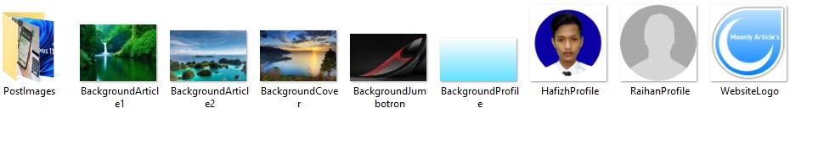File

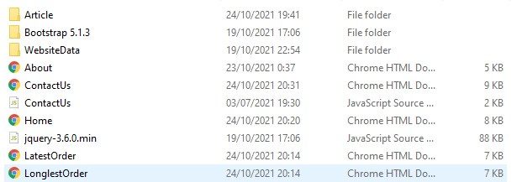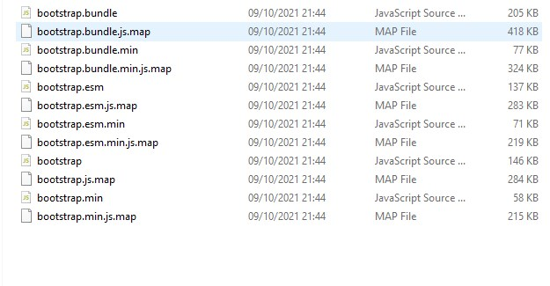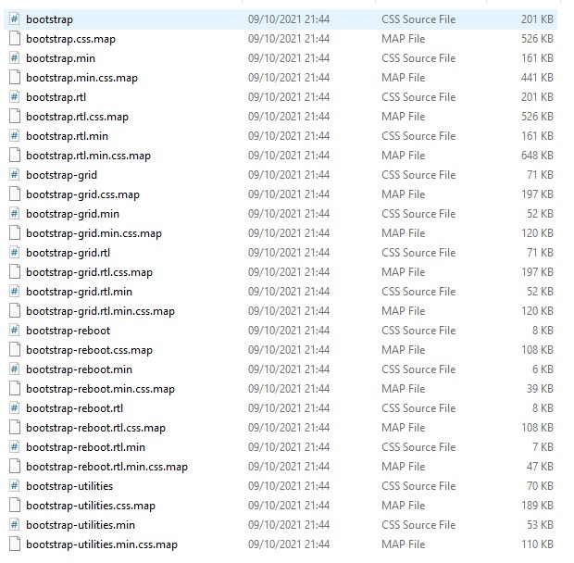

**DESIGN OF APPS**

**DESIGN OF APPS**

1. Home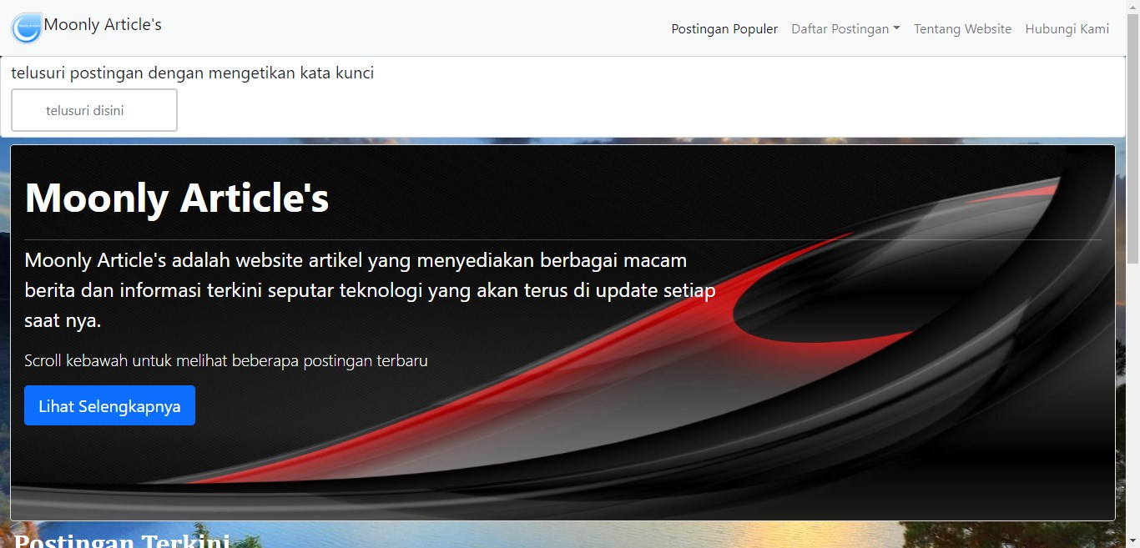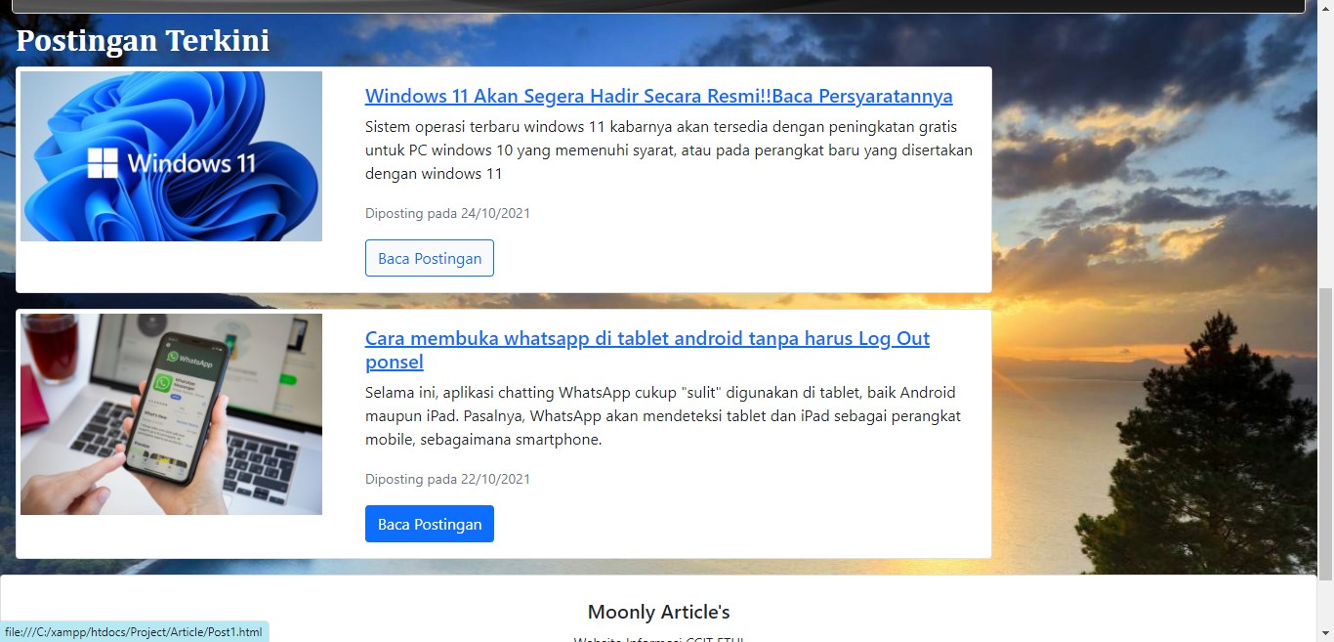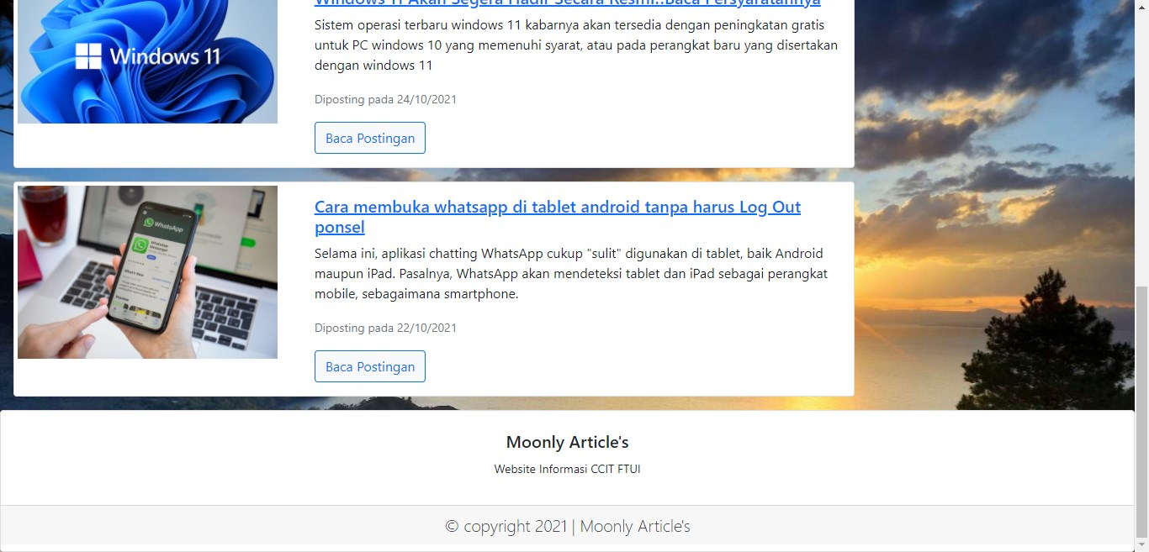

**DESIGN OF APPS**

2.Postingan terbaru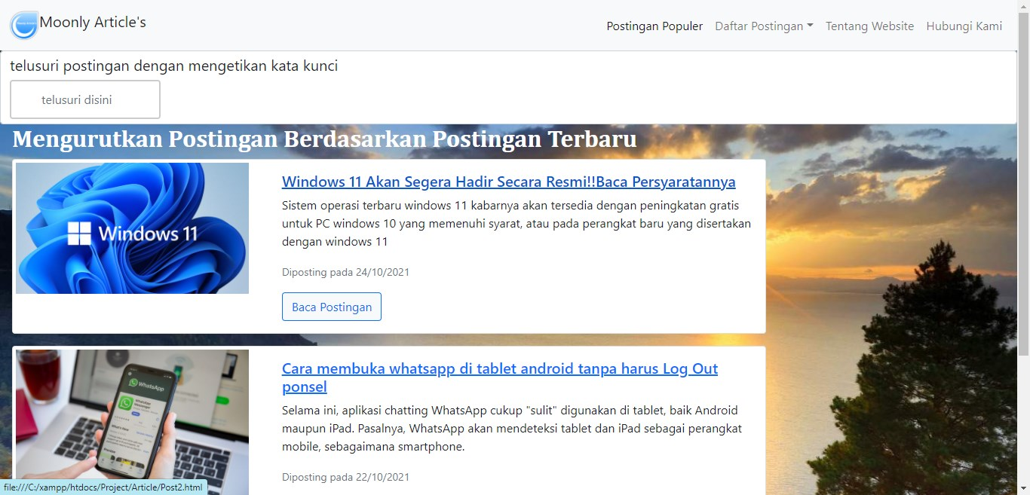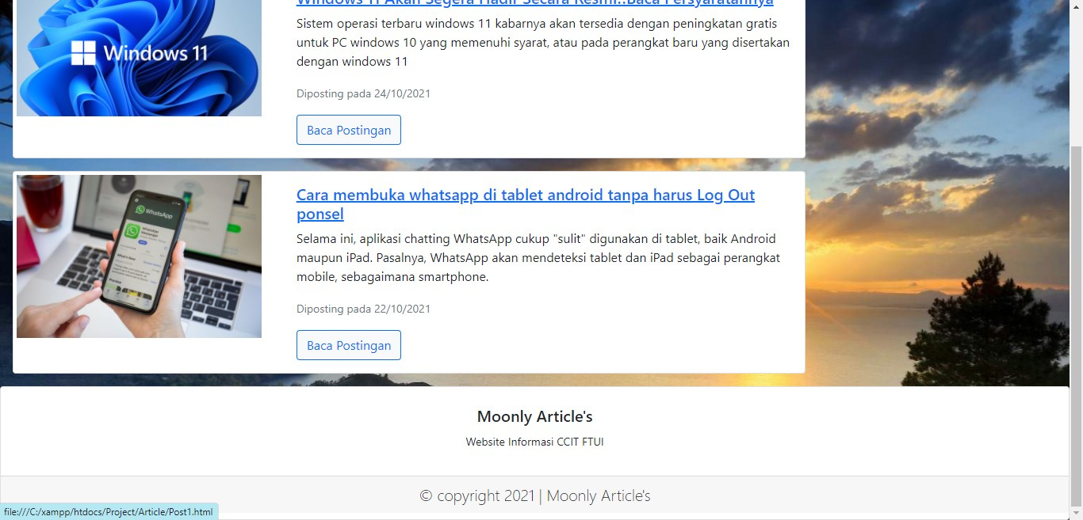

3.Postingan Terlama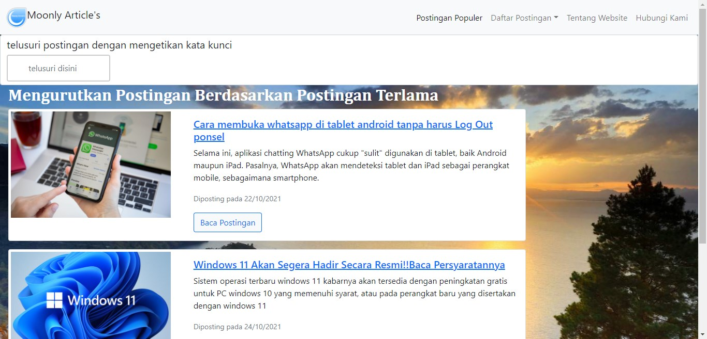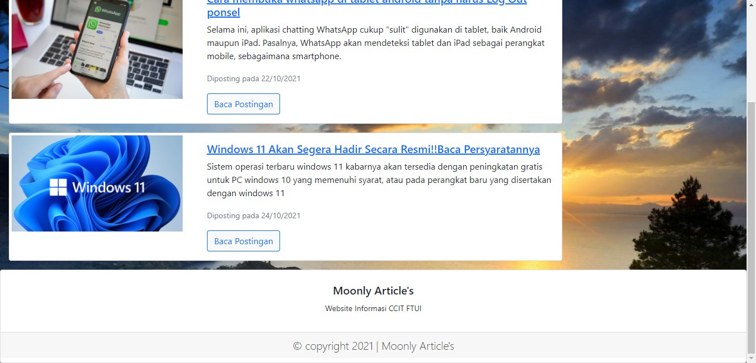

**DESIGN OF APPS**

4.Tentang Website

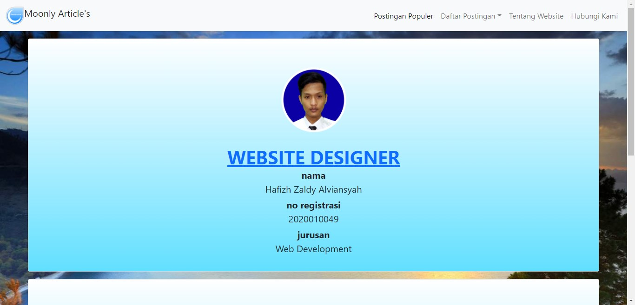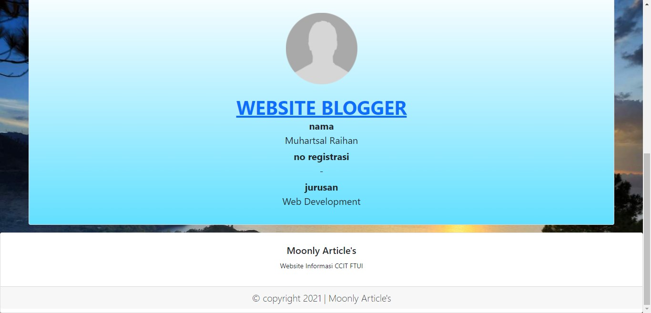

**DESIGN OF APPS**

5.Hubungi Kami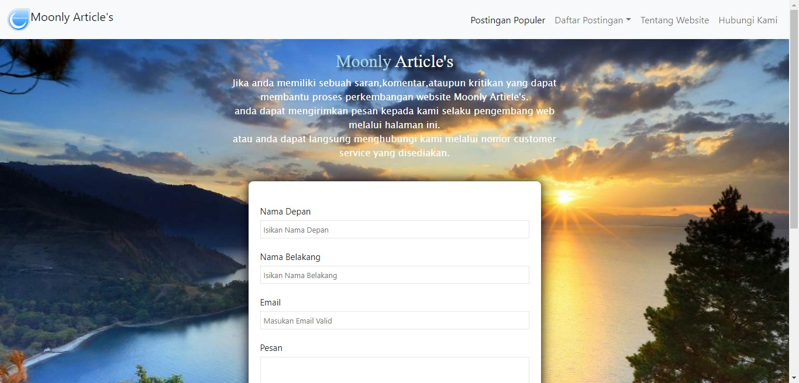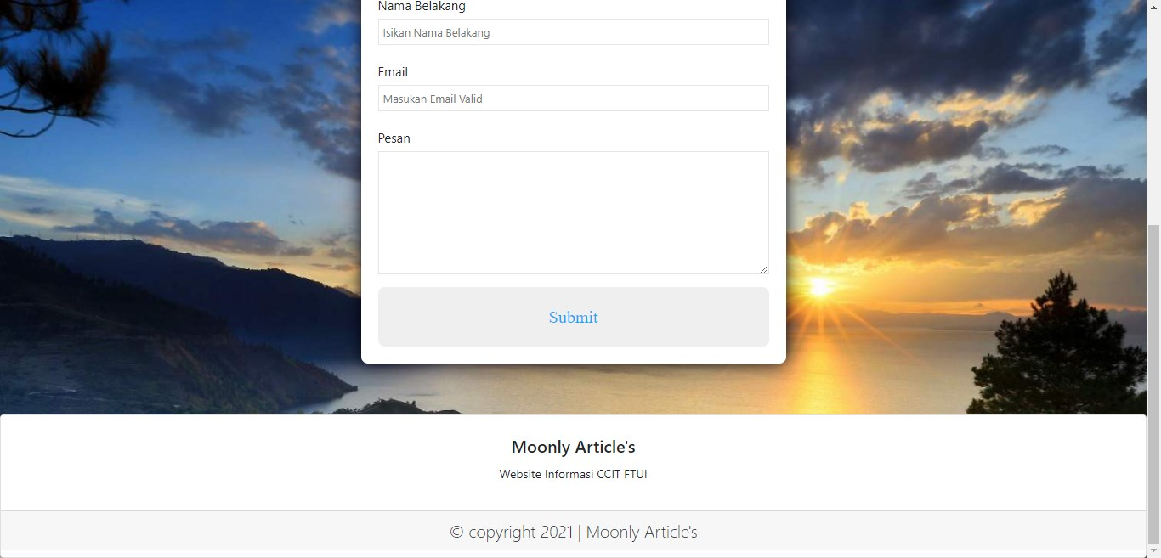

**DESIGN OF APPS**

6..Article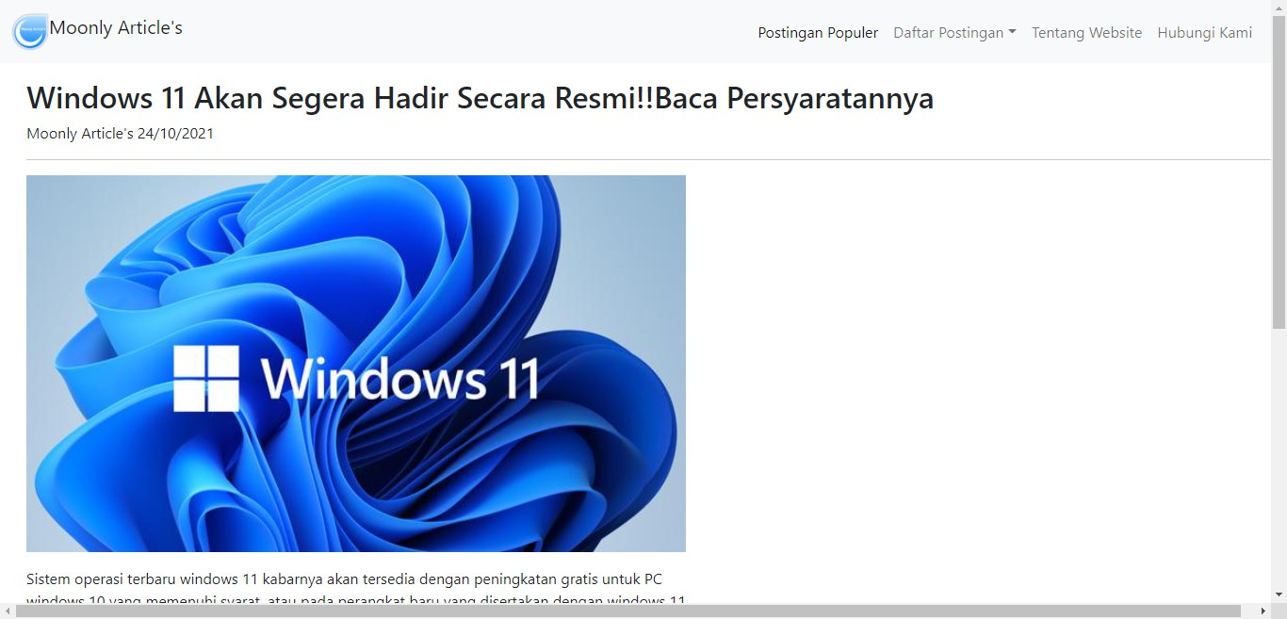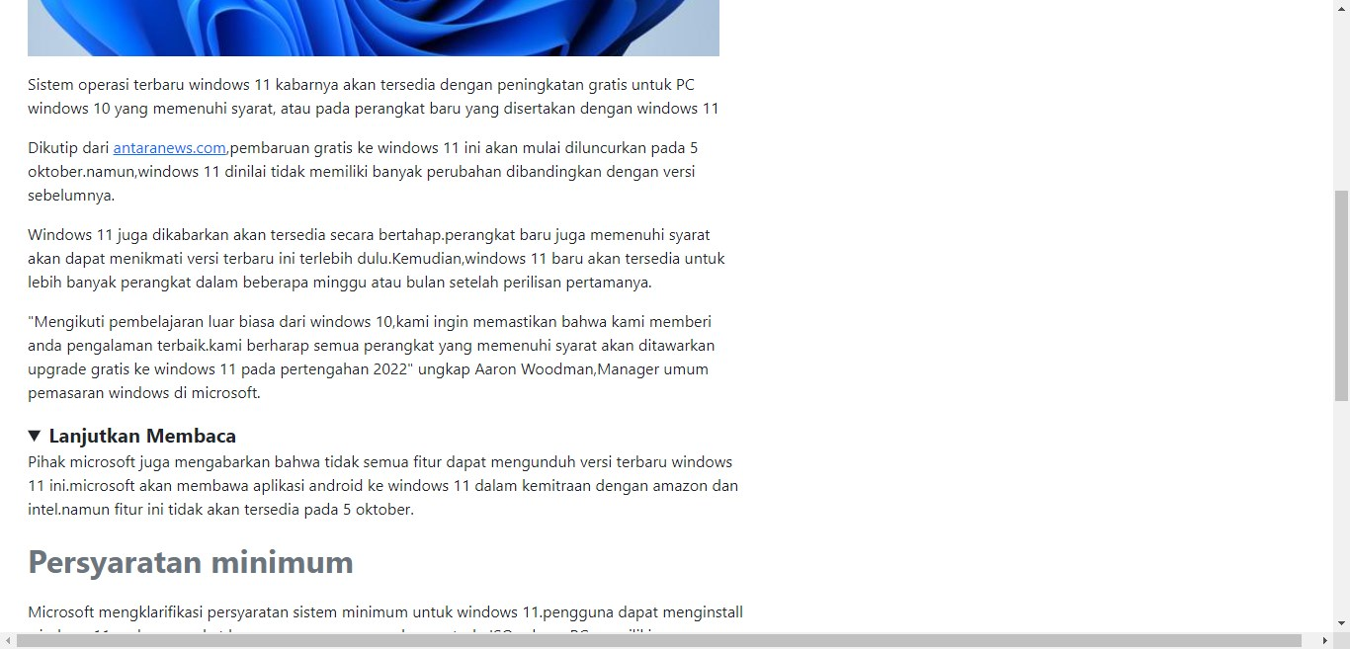

**IMPLEMENTATION**

1.Home.html

<!DOCTYPE html>

<html lang=**"en"**>

<head>

<title>**Moonly Article's**</title>

<meta charset=**"UTF-8"**>

<meta name=**"viewport"** content=**"width=device-width, initial-scale=1"**>

<link rel=**"stylesheet"** type=**"text/css"** href=**"Bootstrap 5.1.3/css/bootstrap.min.css"**>

</head>

<style>

**input[type=search] {**

**width: 200px;**

**box-sizing: border-box;**

**border: 2px solid #ccc;**

**border-radius: 4px;**

**font-size: 16px;**

**background-color: rgb(255, 255, 255);**

**background-image: url('searchicon.png');**

**background-position: 10px 10px;**

**background-repeat: no-repeat;**

**padding: 12px 20px 12px 40px;**

**-webkit-transition: width 0.4s ease-in-out;**

**transition: width 0.4s ease-in-out;**

**}**

**input[type=search]:focus {**

**width: 100%;**

**}**

</style>

<body style=**"background-image: url(WebsiteData/Images/BackgroundCover.jpg); background-size: cover; background-attachment: fixed; background-repeat: no-repeat;"**>

<header>

<nav class=**"navbar navbar-expand-lg navbar-light bg-light"** id=**"mainNav"**>

<div class=**"container-fluid"**>

<a class=**"navbar-brand"** href=**"Home.html"**><img src=**"WebsiteData/Images/WebsiteLogo.png"** alt=**"Website Logo"** width=**"40"** height=**"40"** class=**"d-inline-block align-text-top"**>**Moonly Article's**</a>

<button class=**"navbar-toggler"** type=**"button"** data-bs-toggle=**"collapse"** data-bs-target=**"#navbarNav"** aria-controls=**"navbarNav"** aria-expanded=**"false"** aria-label=**"Toggle navigation"**>

<span class=**"navbar-toggler-icon"**></span>

</button>

<div class=**"collapse navbar-collapse"** id=**"navbarNav"**>

<ul class=**"navbar-nav ms-auto"**>

<li class=**"nav-item"**>

<a class=**"nav-link active"** aria-current=**"page"** href=**"Home.html"**>**Postingan Populer**</a>

</li>

<li class=**"nav-item dropdown"**>

<a class=**"nav-link dropdown-toggle"** href=**"#"** id=**"navbarDropdown"** data-bs-toggle=**"dropdown"** aria-expanded=**"false"**>**Daftar Postingan**</a>

<ul class=**"dropdown-menu"** aria-labelledby=**"navbarDropdown"**>

<li><a class=**"dropdown-item"** href=**"LatestOrder.html"**>**Postingan Terbaru**</a></li>

<li><hr class=**"dropdown-divider"**></li>

<li><a class=**"dropdown-item"** href=**"LonglestOrder.html"**>**Postingan Terlama**</a></li>

</ul>

</li>

<li class=**"nav-item"**>

<a class=**"nav-link"** href=**"About.html"**>**Tentang Website**</a>

</li>

<li class=**"nav-item"**>

<a class=**"nav-link"** href=**"ContactUs.html"**>**Hubungi Kami**</a>

</li>

</ul>

</div>

</div>

</nav>

</header>

<div class=**"form-control"**>

<h5 class=**"lead fw-normal"**>**telusuri postingan dengan mengetikan kata kunci**</h5>

<input type=**"search"** class=**"form-control"** placeholder=**"telusuri disini"**>

</div>

<div class=**"container-fluid"**>

<div class=**"card rounded-3 my-2"**>

<img src=**"WebsiteData/Images/BackgroundJumbotron.jpg"** alt=**"background jumbotron"** class=**"card-img"** height=**"450"**>

<div class=**"card-img-overlay px-3 py-3 text-white"**>

<h1 class=**"card-title display-5 fw-bold py-3"**>**Moonly Article's**</h1>

<hr class=**"my-1"**>

<p class=**"card-text col-md-8 fs-4"**>**Moonly Article's adalah website artikel yang menyediakan berbagai macam berita dan informasi terkini seputar teknologi yang akan terus di update setiap saat nya.**</p>

<p class=**"card-text lead"**>**Scroll kebawah untuk melihat beberapa postingan terbaru**</p>

<a class=**"btn btn-primary btn-lg"** role=**"button"** href=**"#latestArticle"**>**Lihat Selengkapnya**</a>

</div>

</div>

</div>

<article class=**"mx-3"**>

<h3 class=**"fs-2"** style=**"color: white; font-family: Cambria, Cochin, Georgia, Times, 'Times New Roman', serif;"** id=**"latestArticle"**><b>**Postingan Terkini**</b></h3>

<div class=**"card mb-3"** style=**"max-width: 1000px; max-height: 700px;"**>

<div class=**"row"**>

<div class=**"col-md-4"**>

<img src=**"WebsiteData/Images/PostImages/Post2-Header.jpg"** alt=**"Windows 11 Akan Segera Hadir Secara Resmi!!Baca Persyaratannya"** class=**"img-fluid rounded-start p-1"**>

</div>

<div class=**"col-md-8"**>

<div class=**"card-body"**>

<h5 class=**"card-title"**><a href=**"Article/Post2.html"**>**Windows 11 Akan Segera Hadir Secara Resmi!!Baca Persyaratannya**</a></h5>

<p>**Sistem operasi terbaru windows 11 kabarnya akan tersedia dengan peningkatan gratis untuk PC windows 10 yang memenuhi syarat, atau pada perangkat baru yang disertakan dengan windows 11**</p>

<p class=**"card-text"**><small class=**"text-muted"**>**Diposting pada 24/10/2021**</small></p>

<a class=**"btn btn-light btn-outline-primary"** role=**"button"** href=**"Article/Post2.html"**>**Baca Postingan**</a>

</div>

</div>

</div>

</div>

<div class=**"card mb-3"** style=**"max-width: 1000px; max-height: 700px;"**>

<div class=**"row"**>

<div class=**"col-md-4"**>

<img src=**"WebsiteData/Images/PostImages/Post1-Header.jpg"** alt=**"Cara membuka whatsapp di tablet android tanpa harus Log Out ponsel"** class=**"img-fluid rounded-start p-1"**>

</div>

<div class=**"col-md-8"**>

<div class=**"card-body"**>

<h5 class=**"card-title"**><a href=**"Article/Post1.html"**>**Cara membuka whatsapp di tablet android tanpa harus Log Out ponsel**</a></h5>

<p>**Selama ini, aplikasi chatting WhatsApp cukup "sulit" digunakan di tablet, baik Android maupun iPad. Pasalnya, WhatsApp akan mendeteksi tablet dan iPad sebagai perangkat mobile, sebagaimana smartphone.**</p>

<p class=**"card-text"**><small class=**"text-muted"**>**Diposting pada 22/10/2021**</small></p>

<a class=**"btn btn-light btn-outline-primary"** role=**"button"** href=**"Article/Post1.html"**>**Baca Postingan**</a>

</div>

</div>

</div>

</div>

</article>

<footer>

<div class=**"card text-center py-2"**>

<div class=**"card-body"**>

<h5 class=**"card-title"**>**Moonly Article's**</h5>

<p><small>**Website Informasi CCIT FTUI**</small></p>

</div>

<div class=**"card-footer"**>

<p class=**"card-text lead"**>*&copy;* **copyright 2021 | Moonly Article's**</p>

</div>

</div>

</footer>

<script src=**"Bootstrap 5.1.3/js/bootstrap.bundle.min.js"**></script>

<script src=**"jquery-3.6.0.min.js"**></script>

<script>

$**(**"input"**).**on**(**"keyup"**,*function*(){**

$**(**"article .card .row"**).**filter**(*function*(){**

$**(*this*).**toggle**(**$**(*this*).**text**().**toLowerCase**().**indexOf**(**$**(**"input"**).**val**().**toLowerCase**())** **>** **-**1**);**

**})**

**});**

</script>

</body>

</html>

<ul class=**"dropdown-menu"** aria-labelledby=**"navbarDropdown"**>

<li><a class=**"dropdown-item"** href=**"LatestOrder.html"**>**Postingan Terbaru**</a></li>

<li><hr class=**"dropdown-divider"**></li>

<li><a class=**"dropdown-item"** href=**"LonglestOrder.html"**>**Postingan Terlama**</a></li>

</ul>

</li>

<li class=**"nav-item"**>

<a class=**"nav-link"** href=**"About.html"**>**Tentang Website**</a>

</li>

<li class=**"nav-item"**>

<a class=**"nav-link"** href=**"ContactUs.html"**>**Hubungi Kami**</a>

</li>

</ul>

</div>

</div>

</nav>

</header>

<div class=**"form-control"**>

<h5 class=**"lead fw-normal"**>**telusuri postingan dengan mengetikan kata kunci**</h5>

<input type=**"search"** class=**"form-control"** placeholder=**"telusuri disini"**>

</div>

<div class=**"container-fluid"**>

<div class=**"card rounded-3 my-2"**>

<img src=**"WebsiteData/Images/BackgroundJumbotron.jpg"** alt=**"background jumbotron"** class=**"card-img"** height=**"450"**>

<div class=**"card-img-overlay px-3 py-3 text-white"**>

<h1 class=**"card-title display-5 fw-bold py-3"**>**Moonly Article's**</h1>

<hr class=**"my-1"**>

<p class=**"card-text col-md-8 fs-4"**>**Moonly Article's adalah website artikel yang menyediakan berbagai macam berita dan informasi terkini seputar teknologi yang akan terus di update setiap saat nya.**</p>

<p class=**"card-text lead"**>**Scroll kebawah untuk melihat beberapa postingan terbaru**</p>

<a class=**"btn btn-primary btn-lg"** role=**"button"** href=**"#latestArticle"**>**Lihat Selengkapnya**</a>

</div>

</div>

</div>

<article class=**"mx-3"**>

<h3 class=**"fs-2"** style=**"color: white; font-family: Cambria, Cochin, Georgia, Times, 'Times New Roman', serif;"** id=**"latestArticle"**><b>**Postingan Terkini**</b></h3>

<div class=**"card mb-3"** style=**"max-width: 1000px; max-height: 700px;"**>

<div class=**"row"**>

<div class=**"col-md-4"**>

<img src=**"WebsiteData/Images/PostImages/Post2-Header.jpg"** alt=**"Windows 11 Akan Segera Hadir Secara Resmi!!Baca Persyaratannya"** class=**"img-fluid rounded-start p-1"**>

</div>

<div class=**"col-md-8"**>

<div class=**"card-body"**>

<h5 class=**"card-title"**><a href=**"Article/Post2.html"**>**Windows 11 Akan Segera Hadir Secara Resmi!!Baca Persyaratannya**</a></h5>

<p>**Sistem operasi terbaru windows 11 kabarnya akan tersedia dengan peningkatan gratis untuk PC windows 10 yang memenuhi syarat, atau pada perangkat baru yang disertakan dengan windows 11**</p>

<p class=**"card-text"**><small class=**"text-muted"**>**Diposting pada 24/10/2021**</small></p>

<a class=**"btn btn-light btn-outline-primary"** role=**"button"** href=**"Article/Post2.html"**>**Baca Postingan**</a>

</div>

</div>

</div>

</div>

<div class=**"card mb-3"** style=**"max-width: 1000px; max-height: 700px;"**>

<div class=**"row"**>

<div class=**"col-md-4"**>

<img src=**"WebsiteData/Images/PostImages/Post1-Header.jpg"** alt=**"Cara membuka whatsapp di tablet android tanpa harus Log Out ponsel"** class=**"img-fluid rounded-start p-1"**>

</div>

<div class=**"col-md-8"**>

<div class=**"card-body"**>

<h5 class=**"card-title"**><a href=**"Article/Post1.html"**>**Cara membuka whatsapp di tablet android tanpa harus Log Out ponsel**</a></h5>

<p>**Selama ini, aplikasi chatting WhatsApp cukup "sulit" digunakan di tablet, baik Android maupun iPad. Pasalnya, WhatsApp akan mendeteksi tablet dan iPad sebagai perangkat mobile, sebagaimana smartphone.**</p>

<p class=**"card-text"**><small class=**"text-muted"**>**Diposting pada 22/10/2021**</small></p>

<a class=**"btn btn-light btn-outline-primary"** role=**"button"** href=**"Article/Post1.html"**>**Baca Postingan**</a>

</div>

</div>

</div>

</div>

</article>

<footer>

<div class=**"card text-center py-2"**>

<div class=**"card-body"**>

<h5 class=**"card-title"**>**Moonly Article's**</h5>

<p><small>**Website Informasi CCIT FTUI**</small></p>

</div>

<div class=**"card-footer"**>

<p class=**"card-text lead"**>*&copy;* **copyright 2021 | Moonly Article's**</p>

</div>

</div>

</footer>

<script src=**"Bootstrap 5.1.3/js/bootstrap.bundle.min.js"**></script>

<script src=**"jquery-3.6.0.min.js"**></script>

<script>

$**(**"input"**).**on**(**"keyup"**,*function*(){**

$**(**"article .card .row"**).**filter**(*function*(){**

$**(*this*).**toggle**(**$**(*this*).**text**().**toLowerCase**().**indexOf**(**$**(**"input"**).**val**().**toLowerCase**())** **>** **-**1**);**

**})**

**});**

</script>

</body>

</html>

**ponsel"** class=**"img-fluid rounded-start p-1"**>

</div>

<div class=**"col-md-8"**>

<div class=**"card-body"**>

<h5 class=**"card-title"**><a href=**"Article/Post1.html"**>**Cara membuka whatsapp di tablet android tanpa harus Log Out ponsel**</a></h5>

<p>**Selama ini, aplikasi chatting WhatsApp cukup "sulit" digunakan di tablet, baik Android maupun iPad. Pasalnya, WhatsApp akan mendeteksi tablet dan iPad sebagai perangkat mobile, sebagaimana smartphone.**</p>

<p class=**"card-text"**><small class=**"text-muted"**>**Diposting pada 22/10/2021**</small></p>

<a class=**"btn btn-light btn-outline-primary"** role=**"button"** href=**"Article/Post1.html"**>**Baca Postingan**</a>

</div>

</div>

</div>

</div>

</article>

<footer>

<div class=**"card text-center py-2"**>

<div class=**"card-body"**>

<h5 class=**"card-title"**>**Moonly Article's**</h5>

<p><small>**Website Informasi CCIT FTUI**</small></p>

</div>

<div class=**"card-footer"**>

<p class=**"card-text lead"**>*&copy;* **copyright 2021 | Moonly Article's**</p>

</div>

</div>

</footer>

<script src=**"Bootstrap 5.1.3/js/bootstrap.bundle.min.js"**></script>

<script src=**"jquery-3.6.0.min.js"**></script>

<script>

$**(**"input"**).**on**(**"keyup"**,*function*(){**

$**(**"article .card .row"**).**filter**(*function*(){**

$**(*this*).**toggle**(**$**(*this*).**text**().**toLowerCase**().**indexOf**(**$**(**"input"**).**val**().**toLowerCase**())** **>** **-**1**);**

**})**

**});**

</script>

</body>

</html>

2.LatestOrder.html

<!DOCTYPE html>

<html lang=**"en"**>

<head>

<title>**Moonly Article's**</title>

<meta charset=**"UTF-8"**>

<meta name=**"viewport"** content=**"width=device-width, initial-scale=1"**>

<link rel=**"stylesheet"** type=**"text/css"** href=**"Bootstrap 5.1.3/css/bootstrap.min.css"**>

</head>

<style>

**input[type=search] {**

**width: 200px;**

**box-sizing: border-box;**

**border: 2px solid #ccc;**

**border-radius: 4px;**

**font-size: 16px;**

**background-color: rgb(255, 255, 255);**

**background-image: url('searchicon.png');**

**background-position: 10px 10px;**

**background-repeat: no-repeat;**

**padding: 12px 20px 12px 40px;**

**-webkit-transition: width 0.4s ease-in-out;**

**transition: width 0.4s ease-in-out;**

**}**

**input[type=search]:focus {**

**width: 100%;**

**}**

</style>

<body style=**"background-image: url(WebsiteData/Images/BackgroundCover.jpg); background-size: cover; background-attachment: fixed; background-repeat: no-repeat;"**>

<header>

<nav class=**"navbar navbar-expand-lg navbar-light bg-light"** id=**"mainNav"**>

<div class=**"container-fluid"**>

<a class=**"navbar-brand"** href=**"Home.html"**><img src=**"WebsiteData/Images/WebsiteLogo.png"** alt=**"Website Logo"** width=**"40"** height=**"40"** class=**"d-inline-block align-text-top"**>**Moonly Article's**</a>

<button class=**"navbar-toggler"** type=**"button"** data-bs-toggle=**"collapse"** data-bs-target=**"#navbarNav"** aria-controls=**"navbarNav"** aria-expanded=**"false"** aria-label=**"Toggle navigation"**>

<span class=**"navbar-toggler-icon"**></span>

</button>

<div class=**"collapse navbar-collapse"** id=**"navbarNav"**>

<ul class=**"navbar-nav ms-auto"**>

<li class=**"nav-item"**>

<a class=**"nav-link active"** aria-current=**"page"** href=**"Home.html"**>**Postingan Populer**</a>

</li>

<li class=**"nav-item dropdown"**>

<a class=**"nav-link dropdown-toggle"** href=**"#"** id=**"navbarDropdown"** data-bs-toggle=**"dropdown"** aria-expanded=**"false"**>**Daftar Postingan**</a>

<ul class=**"dropdown-menu"** aria-labelledby=**"navbarDropdown"**>

<li><a class=**"dropdown-item"** href=**"LatestOrder.html"**>**Postingan Terbaru**</a></li>

<li><hr class=**"dropdown-divider"**></li>

<li><a class=**"dropdown-item"** href=**"LonglestOrder.html"**>**Postingan Terlama**</a></li>

</ul>

</li>

<li class=**"nav-item"**>

<a class=**"nav-link"** href=**"About.html"**>**Tentang Website**</a>

</li>

<li class=**"nav-item"**>

<a class=**"nav-link"** href=**"ContactUs.html"**>**Hubungi Kami**</a>

</li>

</ul>

</div>

</div>

</nav>

</header>

<div class=**"form-control"**>

<h5 class=**"lead fw-normal"**>**telusuri postingan dengan mengetikan kata kunci**</h5>

<input type=**"search"** class=**"form-control"** placeholder=**"telusuri disini"**>

</div>

<article class=**"mx-3"**>

<h3 class=**"fs-2"** style=**"color: white; font-family: Cambria, Cochin, Georgia, Times, 'Times New Roman', serif;"** id=**"latestArticle"**><b>**Mengurutkan Postingan Berdasarkan Postingan Terbaru**</b></h3>

<div class=**"card mb-3"** style=**"max-width: 1000px; max-height: 700px;"**>

<div class=**"row"**>

<div class=**"col-md-4"**>

<img src=**"WebsiteData/Images/PostImages/Post2-Header.jpg"** alt=**"Windows 11 Akan Segera Hadir Secara Resmi!!Baca Persyaratannya"** class=**"img-fluid rounded-start p-1"**>

</div>

<div class=**"col-md-8"**>

<div class=**"card-body"**>

<h5 class=**"card-title"**><a href=**"Article/Post2.html"**>**Windows 11 Akan Segera Hadir Secara Resmi!!Baca Persyaratannya**</a></h5>

<p>**Sistem operasi terbaru windows 11 kabarnya akan tersedia dengan peningkatan gratis untuk PC windows 10 yang memenuhi syarat, atau pada perangkat baru yang disertakan dengan windows 11**</p>

<p class=**"card-text"**><small class=**"text-muted"**>**Diposting pada 24/10/2021**</small></p>

<a class=**"btn btn-light btn-outline-primary"** role=**"button"** href=**"Article/Post2.html"**>**Baca Postingan**</a>

</div>

</div>

</div>

</div>

<div class=**"card mb-3"** style=**"max-width: 1000px; max-height: 700px;"**>

<div class=**"row"**>

<div class=**"col-md-4"**>

<img src=**"WebsiteData/Images/PostImages/Post1-Header.jpg"** alt=**"Cara membuka whatsapp di tablet android tanpa harus Log Out ponsel"** class=**"img-fluid rounded-start p-1"**>

</div>

<div class=**"col-md-8"**>

<div class=**"card-body"**>

<h5 class=**"card-title"**><a href=**"Article/Post1.html"**>**Cara membuka whatsapp di tablet android tanpa harus Log Out ponsel**</a></h5>

<p>**Selama ini, aplikasi chatting WhatsApp cukup "sulit" digunakan di tablet, baik Android maupun iPad. Pasalnya, WhatsApp akan mendeteksi tablet dan iPad sebagai perangkat mobile, sebagaimana smartphone.**</p>

<p class=**"card-text"**><small class=**"text-muted"**>**Diposting pada 22/10/2021**</small></p>

<a class=**"btn btn-light btn-outline-primary"** role=**"button"** href=**"Article/Post1.html"**>**Baca Postingan**</a>

</div>

</div>

</div>

</div>

</article>

<footer>

<div class=**"card text-center py-2"**>

<div class=**"card-body"**>

<h5 class=**"card-title"**>**Moonly Article's**</h5>

<p><small>**Website Informasi CCIT FTUI**</small></p>

</div>

<div class=**"card-footer"**>

<p class=**"card-text lead"**>*&copy;* **copyright 2021 | Moonly Article's**</p>

</div>

</div>

</footer>

<script src=**"Bootstrap 5.1.3/js/bootstrap.bundle.min.js"**></script>

<script src=**"jquery-3.6.0.min.js"**></script>

<script>

$**(**"input"**).**on**(**"keyup"**,*function*(){**

$**(**"article .card .row"**).**filter**(*function*(){**

$**(*this*).**toggle**(**$**(*this*).**text**().**toLowerCase**().**indexOf**(**$**(**"input"**).**val**().**toLowerCase**())** **>** **-**1**);**

**})**

**});**

</script>

</body>

</html>

<header>

<nav class=**"navbar navbar-expand-lg navbar-light bg-light"** id=**"mainNav"**>

<div class=**"container-fluid"**>

<a class=**"navbar-brand"** href=**"Home.html"**><img src=**"WebsiteData/Images/WebsiteLogo.png"** alt=**"Website Logo"** width=**"40"** height=**"40"** class=**"d-inline-block align-text-top"**>**Moonly Article's**</a>

<button class=**"navbar-toggler"** type=**"button"** data-bs-toggle=**"collapse"** data-bs-target=**"#navbarNav"** aria-controls=**"navbarNav"** aria-expanded=**"false"** aria-label=**"Toggle navigation"**>

<span class=**"navbar-toggler-icon"**></span>

</button>

<div class=**"collapse navbar-collapse"** id=**"navbarNav"**>

<ul class=**"navbar-nav ms-auto"**>

<li class=**"nav-item"**>

<a class=**"nav-link active"** aria-current=**"page"** href=**"Home.html"**>**Postingan Populer**</a>

</li>

<li class=**"nav-item dropdown"**>

<a class=**"nav-link dropdown-toggle"** href=**"#"** id=**"navbarDropdown"** data-bs-toggle=**"dropdown"** aria-expanded=**"false"**>**Daftar Postingan**</a>

<ul class=**"dropdown-menu"** aria-labelledby=**"navbarDropdown"**>

<li><a class=**"dropdown-item"** href=**"LatestOrder.html"**>**Postingan Terbaru**</a></li>

<li><hr class=**"dropdown-divider"**></li>

<li><a class=**"dropdown-item"** href=**"LonglestOrder.html"**>**Postingan Terlama**</a></li>

</ul>

</li>

<li class=**"nav-item"**>

<a class=**"nav-link"** href=**"About.html"**>**Tentang Website**</a>

</li>

<li class=**"nav-item"**>

<a class=**"nav-link"** href=**"ContactUs.html"**>**Hubungi Kami**</a>

</li>

</ul>

</div>

</div>

</nav>

</header>

<div class=**"form-control"**>

<h5 class=**"lead fw-normal"**>**telusuri postingan dengan mengetikan kata kunci**</h5>

<input type=**"search"** class=**"form-control"** placeholder=**"telusuri disini"**>

</div>

<article class=**"mx-3"**>

<h3 class=**"fs-2"** style=**"color: white; font-family: Cambria, Cochin, Georgia, Times, 'Times New Roman', serif;"** id=**"latestArticle"**><b>**Mengurutkan Postingan Berdasarkan Postingan Terbaru**</b></h3>

<div class=**"card mb-3"** style=**"max-width: 1000px; max-height: 700px;"**>

<div class=**"row"**>

<div class=**"col-md-4"**>

<img src=**"WebsiteData/Images/PostImages/Post2-Header.jpg"** alt=**"Windows 11 Akan Segera Hadir Secara Resmi!!Baca Persyaratannya"** class=**"img-fluid rounded-start p-1"**>

</div>

<div class=**"col-md-8"**>

<div class=**"card-body"**>

<h5 class=**"card-title"**><a href=**"Article/Post2.html"**>**Windows 11 Akan Segera Hadir Secara Resmi!!Baca Persyaratannya**</a></h5>

<p>**Sistem operasi terbaru windows 11 kabarnya akan tersedia dengan peningkatan gratis untuk PC windows 10 yang memenuhi syarat, atau pada perangkat baru yang disertakan dengan windows 11**</p>

<p class=**"card-text"**><small class=**"text-muted"**>**Diposting pada 24/10/2021**</small></p>

<a class=**"btn btn-light btn-outline-primary"** role=**"button"** href=**"Article/Post2.html"**>**Baca Postingan**</a>

</div>

</div>

</div>

</div>

<div class=**"card mb-3"** style=**"max-width: 1000px; max-height: 700px;"**>

<div class=**"row"**>

<div class=**"col-md-4"**>

<img src=**"WebsiteData/Images/PostImages/Post1-Header.jpg"** alt=**"Cara membuka whatsapp di tablet android tanpa harus Log Out ponsel"** class=**"img-fluid rounded-start p-1"**>

</div>

<div class=**"col-md-8"**>

<div class=**"card-body"**>

<h5 class=**"card-title"**><a href=**"Article/Post1.html"**>**Cara membuka whatsapp di tablet android tanpa harus Log Out ponsel**</a></h5>

<p>**Selama ini, aplikasi chatting WhatsApp cukup "sulit" digunakan di tablet, baik Android maupun iPad. Pasalnya, WhatsApp akan mendeteksi tablet dan iPad sebagai perangkat mobile, sebagaimana smartphone.**</p>

<p class=**"card-text"**><small class=**"text-muted"**>**Diposting pada 22/10/2021**</small></p>

<a class=**"btn btn-light btn-outline-primary"** role=**"button"** href=**"Article/Post1.html"**>**Baca Postingan**</a>

</div>

</div>

</div>

</div>

</article>

<footer>

<div class=**"card text-center py-2"**>

<div class=**"card-body"**>

<h5 class=**"card-title"**>**Moonly Article's**</h5>

<p><small>**Website Informasi CCIT FTUI**</small></p>

</div>

<div class=**"card-footer"**>

<p class=**"card-text lead"**>*&copy;* **copyright 2021 | Moonly Article's**</p>

</div>

</div>

</footer>

<script src=**"Bootstrap 5.1.3/js/bootstrap.bundle.min.js"**></script>

<script src=**"jquery-3.6.0.min.js"**></script>

<script>

$**(**"input"**).**on**(**"keyup"**,*function*(){**

$**(**"article .card .row"**).**filter**(*function*(){**

$**(*this*).**toggle**(**$**(*this*).**text**().**toLowerCase**().**indexOf**(**$**(**"input"**).**val**().**toLowerCase**())** **>** **-**1**);**

**})**

**});**

</script>

</body>

</html>

<div class=**"row"**>

<div class=**"col-md-4"**>

<img src=**"WebsiteData/Images/PostImages/Post1-Header.jpg"** alt=**"Cara membuka whatsapp di tablet android tanpa harus Log Out ponsel"** class=**"img-fluid rounded-start p-1"**>

</div>

<div class=**"col-md-8"**>

<div class=**"card-body"**>

<h5 class=**"card-title"**><a href=**"Article/Post1.html"**>**Cara membuka whatsapp di tablet android tanpa harus** **Log Out ponsel**</a></h5>

<p>**Selama ini, aplikasi chatting WhatsApp cukup "sulit" digunakan di tablet, baik Android maupun iPad. Pasalnya, WhatsApp akan mendeteksi tablet dan iPad sebagai perangkat mobile, sebagaimana smartphone.**</p>

<p class=**"card-text"**><small class=**"text-muted"**>**Diposting pada 22/10/2021**</small></p>

<a class=**"btn btn-light btn-outline-primary"** role=**"button"** href=**"Article/Post1.html"**>**Baca Postingan**</a>

</div>

</div>

</div>

</div>

</article>

<footer>

<div class=**"card text-center py-2"**>

<div class=**"card-body"**>

<h5 class=**"card-title"**>**Moonly Article's**</h5>

<p><small>**Website Informasi CCIT FTUI**</small></p>

</div>

<div class=**"card-footer"**>

<p class=**"card-text lead"**>*&copy;* **copyright 2021 | Moonly Article's**</p>

</div>

</div>

</footer>

<script src=**"Bootstrap 5.1.3/js/bootstrap.bundle.min.js"**></script>

<script src=**"jquery-3.6.0.min.js"**></script>

<script>

$**(**"input"**).**on**(**"keyup"**,*function*(){**

$**(**"article .card .row"**).**filter**(*function*(){**

$**(*this*).**toggle**(**$**(*this*).**text**().**toLowerCase**().**indexOf**(**$**(**"input"**).**val**().**toLowerCase**())** **>** **-**1**);**

**})**

**});**

</script>

</body>

</html>

3.LongestOrder.html

<!DOCTYPE html>

<html lang=**"en"**>

<head>

<title>**Moonly Article's**</title>

<meta charset=**"UTF-8"**>

<meta name=**"viewport"** content=**"width=device-width, initial-scale=1"**>

<link rel=**"stylesheet"** type=**"text/css"** href=**"Bootstrap 5.1.3/css/bootstrap.min.css"**>

</head>

<style>

**input[type=search] {**

**width: 200px;**

**box-sizing: border-box;**

**border: 2px solid #ccc;**

**border-radius: 4px;**

**font-size: 16px;**

**background-color: rgb(255, 255, 255);**

**background-image: url('searchicon.png');**

**background-position: 10px 10px;**

**background-repeat: no-repeat;**

**padding: 12px 20px 12px 40px;**

**-webkit-transition: width 0.4s ease-in-out;**

**transition: width 0.4s ease-in-out;**

**}**

**input[type=search]:focus {**

**width: 100%;**

**}**

</style>

<body style=**"background-image: url(WebsiteData/Images/BackgroundCover.jpg); background-size: cover; background-attachment: fixed; background-repeat: no-repeat;"**>

<header>

<nav class=**"navbar navbar-expand-lg navbar-light bg-light"** id=**"mainNav"**>

<div class=**"container-fluid"**>

<a class=**"navbar-brand"** href=**"Home.html"**><img src=**"WebsiteData/Images/WebsiteLogo.png"** alt=**"Website Logo"** width=**"40"** height=**"40"** class=**"d-inline-block align-text-top"**>**Moonly Article's**</a>

<button class=**"navbar-toggler"** type=**"button"** data-bs-toggle=**"collapse"** data-bs-target=**"#navbarNav"** aria-controls=**"navbarNav"** aria-expanded=**"false"** aria-label=**"Toggle navigation"**>

<span class=**"navbar-toggler-icon"**></span>

</button>

<div class=**"collapse navbar-collapse"** id=**"navbarNav"**>

<ul class=**"navbar-nav ms-auto"**>

<li class=**"nav-item"**>

<a class=**"nav-link active"** aria-current=**"page"** href=**"Home.html"**>**Postingan Populer**</a>

</li>

<li class=**"nav-item dropdown"**>

<a class=**"nav-link dropdown-toggle"** href=**"#"** id=**"navbarDropdown"** data-bs-toggle=**"dropdown"** aria-expanded=**"false"**>**Daftar Postingan**</a>

<ul class=**"dropdown-menu"** aria-labelledby=**"navbarDropdown"**>

<li><a class=**"dropdown-item"** href=**"LatestOrder.html"**>**Postingan Terbaru**</a></li>

<li><hr class=**"dropdown-divider"**></li>

<li><a class=**"dropdown-item"** href=**"LonglestOrder.html"**>**Postingan Terlama**</a></li>

</ul>

</li>

<li class=**"nav-item"**>

<a class=**"nav-link"** href=**"About.html"**>**Tentang Website**</a>

</li>

<li class=**"nav-item"**>

<a class=**"nav-link"** href=**"ContactUs.html"**>**Hubungi Kami**</a>

</li>

</ul>

</div>

</div>

</nav>

</header>

<div class=**"form-control"**>

<h5 class=**"lead fw-normal"**>**telusuri postingan dengan mengetikan kata kunci**</h5>

<input type=**"search"** class=**"form-control"** placeholder=**"telusuri disini"**>

</div>

<article class=**"mx-3"**>

<h3 class=**"fs-2"** style=**"color: white; font-family: Cambria, Cochin, Georgia, Times, 'Times New Roman', serif;"** id=**"latestArticle"**><b>**Mengurutkan Postingan Berdasarkan Postingan Terlama**</b></h3>

<div class=**"card mb-3"** style=**"max-width: 1000px; max-height: 700px;"**>

<div class=**"row"**>

<div class=**"col-md-4"**>

<img src=**"WebsiteData/Images/PostImages/Post1-Header.jpg"** alt=**"Cara membuka whatsapp di tablet android tanpa harus Log Out ponsel"** class=**"img-fluid rounded-start p-1"**>

</div>

<div class=**"col-md-8"**>

<div class=**"card-body"**>

<h5 class=**"card-title"**><a href=**"Article/Post1.html"**>**Cara membuka whatsapp di tablet android tanpa harus Log Out ponsel**</a></h5>

<p>**Selama ini, aplikasi chatting WhatsApp cukup "sulit" digunakan di tablet, baik Android maupun iPad. Pasalnya, WhatsApp akan mendeteksi tablet dan iPad sebagai perangkat mobile, sebagaimana smartphone.**</p>

<p class=**"card-text"**><small class=**"text-muted"**>**Diposting pada 22/10/2021**</small></p>

<a class=**"btn btn-light btn-outline-primary"** role=**"button"** href=**"Article/Post1.html"**>**Baca Postingan**</a>

</div>

</div>

</div>

</div>

<div class=**"card mb-3"** style=**"max-width: 1000px; max-height: 700px;"**>

<div class=**"row"**>

<div class=**"col-md-4"**>

<img src=**"WebsiteData/Images/PostImages/Post2-Header.jpg"** alt=**"Windows 11 Akan Segera Hadir Secara Resmi!!Baca Persyaratannya"** class=**"img-fluid rounded-start p-1"**>

</div>

<div class=**"col-md-8"**>

<div class=**"card-body"**>

<h5 class=**"card-title"**><a href=**"Article/Post2.html"**>**Windows 11 Akan Segera Hadir Secara Resmi!!Baca Persyaratannya**</a></h5>

<p>**Sistem operasi terbaru windows 11 kabarnya akan tersedia dengan peningkatan gratis untuk PC windows 10 yang memenuhi syarat, atau pada perangkat baru yang disertakan dengan windows 11**</p>

<p class=**"card-text"**><small class=**"text-muted"**>**Diposting pada 24/10/2021**</small></p>

<a class=**"btn btn-light btn-outline-primary"** role=**"button"** href=**"Article/Post2.html"**>**Baca Postingan**</a>

</div>

</div>

</div>

</div>

</article>

<footer>

<div class=**"card text-center py-2"**>

<div class=**"card-body"**>

<h5 class=**"card-title"**>**Moonly Article's**</h5>

<p><small>**Website Informasi CCIT FTUI**</small></p>

</div>

<div class=**"card-footer"**>

<p class=**"card-text lead"**>*&copy;* **copyright 2021 | Moonly Article's**</p>

</div>

</div>

</footer>

<script src=**"Bootstrap 5.1.3/js/bootstrap.bundle.min.js"**></script>

<script src=**"jquery-3.6.0.min.js"**></script>

<script>

$**(**"input"**).**on**(**"keyup"**,*function*(){**

$**(**"article .card .row"**).**filter**(*function*(){**

$**(*this*).**toggle**(**$**(*this*).**text**().**toLowerCase**().**indexOf**(**$**(**"input"**).**val**().**toLowerCase**())** **>** **-**1**);**

**})**

**});**

</script>

</body>

</html>

**background-size: cover; background-attachment: fixed; background-repeat: no-repeat;"**>

<header>

<nav class=**"navbar navbar-expand-lg navbar-light bg-light"** id=**"mainNav"**>

<div class=**"container-fluid"**>

<a class=**"navbar-brand"** href=**"Home.html"**><img src=**"WebsiteData/Images/WebsiteLogo.png"** alt=**"Website Logo"** width=**"40"** height=**"40"** class=**"d-inline-block align-text-top"**>**Moonly Article's**</a>

<button class=**"navbar-toggler"** type=**"button"** data-bs-toggle=**"collapse"** data-bs-target=**"#navbarNav"** aria-controls=**"navbarNav"** aria-expanded=**"false"** aria-label=**"Toggle navigation"**>

<span class=**"navbar-toggler-icon"**></span>

</button>

<div class=**"collapse navbar-collapse"** id=**"navbarNav"**>

<ul class=**"navbar-nav ms-auto"**>

<li class=**"nav-item"**>

<a class=**"nav-link active"** aria-current=**"page"** href=**"Home.html"**>**Postingan Populer**</a>

</li>

<li class=**"nav-item dropdown"**>

<a class=**"nav-link dropdown-toggle"** href=**"#"** id=**"navbarDropdown"** data-bs-toggle=**"dropdown"** aria-expanded=**"false"**>**Daftar Postingan**</a>

<ul class=**"dropdown-menu"** aria-labelledby=**"navbarDropdown"**>

<li><a class=**"dropdown-item"** href=**"LatestOrder.html"**>**Postingan Terbaru**</a></li>

<li><hr class=**"dropdown-divider"**></li>

<li><a class=**"dropdown-item"** href=**"LonglestOrder.html"**>**Postingan Terlama**</a></li>

</ul>

</li>

<li class=**"nav-item"**>

<a class=**"nav-link"** href=**"About.html"**>**Tentang Website**</a>

</li>

<li class=**"nav-item"**>

<a class=**"nav-link"** href=**"ContactUs.html"**>**Hubungi Kami**</a>

</li>

</ul>

</div>

</div>

</nav>

</header>

<div class=**"form-control"**>

<h5 class=**"lead fw-normal"**>**telusuri postingan dengan mengetikan kata kunci**</h5>

<input type=**"search"** class=**"form-control"** placeholder=**"telusuri disini"**>

</div>

<article class=**"mx-3"**>

<h3 class=**"fs-2"** style=**"color: white; font-family: Cambria, Cochin, Georgia, Times, 'Times New Roman', serif;"** id=**"latestArticle"**><b>**Mengurutkan Postingan Berdasarkan Postingan Terlama**</b></h3>

<div class=**"card mb-3"** style=**"max-width: 1000px; max-height: 700px;"**>

<div class=**"row"**>

<div class=**"col-md-4"**>

<img src=**"WebsiteData/Images/PostImages/Post1-Header.jpg"** alt=**"Cara membuka whatsapp di tablet android tanpa harus Log Out ponsel"** class=**"img-fluid rounded-start p-1"**>

</div>

<div class=**"col-md-8"**>

<div class=**"card-body"**>

<h5 class=**"card-title"**><a href=**"Article/Post1.html"**>**Cara membuka whatsapp di tablet android tanpa harus Log Out ponsel**</a></h5>

<p>**Selama ini, aplikasi chatting WhatsApp cukup "sulit" digunakan di tablet, baik Android maupun iPad. Pasalnya, WhatsApp akan mendeteksi tablet dan iPad sebagai perangkat mobile, sebagaimana smartphone.**</p>

<p class=**"card-text"**><small class=**"text-muted"**>**Diposting pada 22/10/2021**</small></p>

<a class=**"btn btn-light btn-outline-primary"** role=**"button"** href=**"Article/Post1.html"**>**Baca Postingan**</a>

</div>

</div>

</div>

</div>

<div class=**"card mb-3"** style=**"max-width: 1000px; max-height: 700px;"**>

<div class=**"row"**>

<div class=**"col-md-4"**>

<img src=**"WebsiteData/Images/PostImages/Post2-Header.jpg"** alt=**"Windows 11 Akan Segera Hadir Secara Resmi!!Baca Persyaratannya"** class=**"img-fluid rounded-start p-1"**>

</div>

<div class=**"col-md-8"**>

<div class=**"card-body"**>

<h5 class=**"card-title"**><a href=**"Article/Post2.html"**>**Windows 11 Akan Segera Hadir Secara Resmi!!Baca Persyaratannya**</a></h5>

<p>**Sistem operasi terbaru windows 11 kabarnya akan tersedia dengan peningkatan gratis untuk PC windows 10 yang memenuhi syarat, atau pada perangkat baru yang disertakan dengan windows 11**</p>

<p class=**"card-text"**><small class=**"text-muted"**>**Diposting pada 24/10/2021**</small></p>

<a class=**"btn btn-light btn-outline-primary"** role=**"button"** href=**"Article/Post2.html"**>**Baca Postingan**</a>

</div>

</div>

</div>

</div>

</article>

<footer>

<div class=**"card text-center py-2"**>

<div class=**"card-body"**>

<h5 class=**"card-title"**>**Moonly Article's**</h5>

<p><small>**Website Informasi CCIT FTUI**</small></p>

</div>

<div class=**"card-footer"**>

<p class=**"card-text lead"**>*&copy;* **copyright 2021 | Moonly Article's**</p>

</div>

</div>

</footer>

<script src=**"Bootstrap 5.1.3/js/bootstrap.bundle.min.js"**></script>

<script src=**"jquery-3.6.0.min.js"**></script>

<script>

$**(**"input"**).**on**(**"keyup"**,*function*(){**

$**(**"article .card .row"**).**filter**(*function*(){**

$**(*this*).**toggle**(**$**(*this*).**text**().**toLowerCase**().**indexOf**(**$**(**"input"**).**val**().**toLowerCase**())** **>** **-**1**);**

**})**

**});**

</script>

</body>

</html>

<div class=**"row"**>

<div class=**"col-md-4"**>

<img src=**"WebsiteData/Images/PostImages/Post2-Header.jpg"** alt=**"Windows 11 Akan Segera Hadir Secara Resmi!!Baca Persyaratannya"** class=**"img-fluid rounded-start p-1"**>

</div>

<div class=**"col-md-8"**>

<div class=**"card-body"**>

<h5 class=**"card-title"**><a href=**"Article/Post2.html"**>**Windows 11 Akan Segera Hadir Secara Resmi!!Baca Persyaratannya**</a></h5>

<p>**Sistem operasi terbaru windows 11 kabarnya akan tersedia dengan peningkatan gratis untuk PC windows 10 yang memenuhi syarat, atau pada perangkat baru yang disertakan dengan windows 11**</p>

<p class=**"card-text"**><small class=**"text-muted"**>**Diposting pada 24/10/2021**</small></p>

<a class=**"btn btn-light btn-outline-primary"** role=**"button"** href=**"Article/Post2.html"**>**Baca Postingan**</a>

</div>

</div>

</div>

</div>

</article>

<footer>

<div class=**"card text-center py-2"**>

<div class=**"card-body"**>

<h5 class=**"card-title"**>**Moonly Article's**</h5>

<p><small>**Website Informasi CCIT FTUI**</small></p>

</div>

<div class=**"card-footer"**>

<p class=**"card-text lead"**>*&copy;* **copyright 2021 | Moonly Article's**</p>

</div>

</div>

</footer>

<script src=**"Bootstrap 5.1.3/js/bootstrap.bundle.min.js"**></script>

<script src=**"jquery-3.6.0.min.js"**></script>

<script>

$**(**"input"**).**on**(**"keyup"**,*function*(){**

$**(**"article .card .row"**).**filter**(*function*(){**

$**(*this*).**toggle**(**$**(*this*).**text**().**toLowerCase**().**indexOf**(**$**(**"input"**).**val**().**toLowerCase**())** **>** **-**1**);**

**})**

**});**

</script>

</body>

</html>

4. AboutUs.html

<!DOCTYPE html>

<html lang=**"en"**>

<head>

<title>**Monthly Article**</title>

<meta charset=**"UTF-8"**>

<meta name=**"viewport"** content=**"width=device-width, initial-scale=1"**>

<link rel=**"stylesheet"** type=**"text/css"** href=**"Bootstrap 5.1.3/css/bootstrap.min.css"**>

</head>

<body style=**"background-image: url(WebsiteData/Images/BackgroundCover.jpg); background-size: cover; background-attachment: fixed; background-repeat: no-repeat;"**>

<header>

<nav class=**"navbar navbar-expand-lg navbar-light bg-light"** id=**"mainNav"**>

<div class=**"container-fluid"**>

<a class=**"navbar-brand"** href=**"Home.html"**><img src=**"WebsiteData/Images/WebsiteLogo.png"** alt=**"Website Logo"** width=**"40"** height=**"40"** class=**"d-inline-block align-text-top"**>**Moonly Article's**</a>

<button class=**"navbar-toggler"** type=**"button"** data-bs-toggle=**"collapse"** data-bs-target=**"#navbarNav"** aria-controls=**"navbarNav"** aria-expanded=**"false"** aria-label=**"Toggle navigation"**>

<span class=**"navbar-toggler-icon"**></span>

</button>

<div class=**"collapse navbar-collapse"** id=**"navbarNav"**>

<ul class=**"navbar-nav ms-auto"**>

<li class=**"nav-item"**>

<a class=**"nav-link active"** aria-current=**"page"** href=**"Home.html"**>**Postingan Populer**</a>

</li>

<li class=**"nav-item dropdown"**>

<a class=**"nav-link dropdown-toggle"** href=**"#"** id=**"navbarDropdown"** data-bs-toggle=**"dropdown"** aria-expanded=**"false"**>**Daftar Postingan**</a>

<ul class=**"dropdown-menu"** aria-labelledby=**"navbarDropdown"**>

<li><a class=**"dropdown-item"** href=**"LatestOrder.html"**>**Postingan Terbaru**</a></li>

<li><hr class=**"dropdown-divider"**></li>

<li><a class=**"dropdown-item"** href=**"LonglestOrder.html"**>**Postingan Terlama**</a></li>

</ul>

</li>

<li class=**"nav-item"**>

<a class=**"nav-link"** href=**"About.html"**>**Tentang Website**</a>

</li>

<li class=**"nav-item"**>

<a class=**"nav-link"** href=**"ContactUs.html"**>**Hubungi Kami**</a>

</li>

</ul>

</div>

</div>

</nav>

**</header>**

**<article class="container-fluid">**

**<div class="card bg-light my-3 mx-lg-5">**

**<img src="WebsiteData/Images/BackgroundProfile.jpg" alt="background" class="card-img" height="500px">**

**<div class="card-img-overlay p-2 my-md-5 text-center">**

**<img class="d-block mx-auto mb-4" src="WebsiteData/Images/HafizhProfile.png" alt="Hafizh Zaldy Alviansyah" width="150" height="150">**

**<a class="card-title fw-bold text-primary display-6" role="text">WEBSITE DESIGNER</a>**

**<p class="lead fw-bolder mb-1">nama<br><span class="lead fw-normal">Hafizh Zaldy Alviansyah</span></p>**

**<p class="lead fw-bolder mb-1">no registrasi<br><span class="lead fw-normal">2020010049</span></p>**

**<p class="lead fw-bolder mb-1">jurusan<br><span class="lead fw-normal">Web Development</span></p>**

**</div>**

**</div>**

**<div class="card bg-light my-3 mx-lg-5">**

**<img src="WebsiteData/Images/BackgroundProfile.jpg" alt="background" class="card-img" height="500px">**

**<div class="card-img-overlay p-2 my-md-5 text-center">**

**<img class="d-block mx-auto mb-4" src="WebsiteData/Images/RaihanProfile.png" alt="Muhartsal Raihan" width="150" height="150">**

**<a class="card-title fw-bold text-primary display-6" role="text">WEBSITE BLOGGER</a>**

**<p class="lead fw-bolder mb-1">nama<br><span class="lead fw-normal">Muhartsal Raihan</span></p>**

**<p class="lead fw-bolder mb-1">no registrasi<br><span class="lead fw-normal">-</span></p>**

**<p class="lead fw-bolder mb-1">jurusan<br><span class="lead fw-normal">Web Development</span></p>**

**</div>**

**</div>**

**</article>**

**<footer>**

**<div class="card text-center py-2">**

**<div class="card-body">**

**<h5 class="card-title">Moonly Article's</h5>**

**<p><small>Website Informasi CCIT FTUI</small></p>**

**</div>**

**<div class="card-footer">**

**<p class="card-text lead">&copy; copyright 2021 | Moonly Article's</p>**

**</div>**

**</div>**

**</footer>**

**<script src="Bootstrap 5.1.3/js/bootstrap.bundle.min.js"></script>**

**</body>**

**</html>**

id=**"navbarDropdown"** data-bs-toggle=**"dropdown"** aria-expanded=**"false"**>**Daftar Postingan**</a>

<ul class=**"dropdown-menu"** aria-labelledby=**"navbarDropdown"**>

<li><a class=**"dropdown-item"** href=**"LatestOrder.html"**>**Postingan Terbaru**</a></li>

<li><hr class=**"dropdown-divider"**></li>

<li><a class=**"dropdown-item"** href=**"LonglestOrder.html"**>**Postingan Terlama**</a></li>

</ul>

</li>

<li class=**"nav-item"**>

<a class=**"nav-link"** href=**"About.html"**>**Tentang Website**</a>

</li>

<li class=**"nav-item"**>

<a class=**"nav-link"** href=**"ContactUs.html"**>**Hubungi Kami**</a>

</li>

</ul>

</div>

</div>

</nav>

**</header>**

**<article class="container-fluid">**

**<div class="card bg-light my-3 mx-lg-5">**

**<img src="WebsiteData/Images/BackgroundProfile.jpg" alt="background" class="card-img" height="500px">**

**<div class="card-img-overlay p-2 my-md-5 text-center">**

**<img class="d-block mx-auto mb-4" src="WebsiteData/Images/HafizhProfile.png" alt="Hafizh Zaldy Alviansyah" width="150" height="150">**

**<a class="card-title fw-bold text-primary display-6" role="text">WEBSITE DESIGNER</a>**

**<p class="lead fw-bolder mb-1">nama<br><span class="lead fw-normal">Hafizh Zaldy Alviansyah</span></p>**

**<p class="lead fw-bolder mb-1">no registrasi<br><span class="lead fw-normal">2020010049</span></p>**

**<p class="lead fw-bolder mb-1">jurusan<br><span class="lead fw-normal">Web Development</span></p>**

**</div>**

**</div>**

**<div class="card bg-light my-3 mx-lg-5">**

**<img src="WebsiteData/Images/BackgroundProfile.jpg" alt="background" class="card-img" height="500px">**

**<div class="card-img-overlay p-2 my-md-5 text-center">**

**<img class="d-block mx-auto mb-4" src="WebsiteData/Images/RaihanProfile.png" alt="Muhartsal Raihan" width="150" height="150">**

**<a class="card-title fw-bold text-primary display-6" role="text">WEBSITE BLOGGER</a>**

**<p class="lead fw-bolder mb-1">nama<br><span class="lead fw-normal">Muhartsal Raihan</span></p>**

**<p class="lead fw-bolder mb-1">no registrasi<br><span class="lead fw-normal">-</span></p>**

**<p class="lead fw-bolder mb-1">jurusan<br><span class="lead fw-normal">Web Development</span></p>**

**</div>**

**</div>**

**</article>**

**<footer>**

**<div class="card text-center py-2">**

**<div class="card-body">**

**<h5 class="card-title">Moonly Article's</h5>**

**<p><small>Website Informasi CCIT FTUI</small></p>**

**</div>**

**<div class="card-footer">**

**<p class="card-text lead">&copy; copyright 2021 | Moonly Article's</p>**

**</div>**

**</div>**

**</footer>**

**<script src="Bootstrap 5.1.3/js/bootstrap.bundle.min.js"></script>**

**</body>**

**</html>**

5.ContactUs.html

<!DOCTYPE html>

<html lang=**"en"**>

<head>

<title>**Monthly Article**</title>

<meta charset=**"UTF-8"**>

<meta name=**"viewport"** content=**"width=device-width, initial-scale=1"**>

<link rel=**"stylesheet"** type=**"text/css"** href=**"Bootstrap 5.1.3/css/bootstrap.min.css"**>

</head>

<style>

**.contact_us{**

**margin: 20px;**

**padding: 0;**

**display: flex;**

**align-items: center;**

**justify-content: center;**

**flex-direction: column;**

**}**

**.contact_us_description{**

**font-family: 'Lucida Sans', 'Lucida Sans Regular', 'Lucida Grande', 'Lucida Sans Unicode', Geneva, Verdana, sans-serif;**

**font-size: 16px;**

**position: relative;**

**text-align: center;**

**width: 600px;**

**margin: auto;**

**padding: auto;**

**color: #ffffff;**

**}**

**.contact_us_description h2{**

**text-align: center;**

**font-family: serif;**

**font-size: 30px;**

**font-weight: 300;**

**color: #ffffff;**

**text-shadow: 5px 5px 5px black;**

**}**

**.contact_us_description h2 span{**

**font-size: 30px;**

**color: lightblue;**

**}**

**.contact_us_container{**

**width: 500px;**

**margin: 0 auto;**

**margin-top: 20px;**

**margin-bottom: 20px;**

**padding: 20px;**

**box-shadow: 0px 0px 20px #000010;**

**background-color: white;**

**border-radius: 8px;**

**}**

**.contact_us_container .form_group{**

**width: 100%;**

**margin-top: 20px;**

**font-size: 15px;**

**}**

**.form_group input,.form_group textarea{**

**width: 100%;**

**padding: 5px;**

**font-size: 13px;**

**border: 1px solid rgba(128, 128, 128, 0.199);**

**margin-top: 5px;**

**}**

**textarea{**

**resize: vertical;**

**}**

**button[type="submit"]{**

**width: 100%;**

**border: none;**

**outline: none;**

**padding: 20px;**

**font-size: 20px;**

**border-radius: 8px;**

**font-family: montserrat;**

**color: rgb(27, 166, 247);**

**text-align: center;**

**cursor: pointer;**

**margin-top: 10px;**

**transition: .3s ease background-color;**

**}**

**button[type="submit"]:hover{**

**background-color: rgb(214, 226, 236);**

**}**

**#status{**

**width: 90%;**

**max-width: 500px;**

**text-align: center;**

**padding: 10px;**

**margin: 0 auto;**

**border-radius: 8px;**

**}**

**#status.success{**

**background-color: rgb(211, 250, 153);**

**animation: status 4s ease forwards;**

**}**

**#status.error{**

**background-color: rgb(250, 129, 92);**

**color: white;**

**animation: status 4s ease forwards;**

**}**

**@keyframes status{**

**0%{**

**opacity: 1;**

**pointer-events: all;**

**}**

**90%{**

**opacity: 1;**

**pointer-events: all;**

**}**

**100%{**

**opacity: 0;**

**pointer-events: none;**

**}**

**}**

</style>

<body style=**"background-image: url(WebsiteData/Images/BackgroundCover.jpg); background-size: cover; background-attachment: fixed; background-repeat: no-repeat;"**>

<header>

<nav class=**"navbar navbar-expand-lg navbar-light bg-light"** id=**"mainNav"**>

<div class=**"container-fluid"**>

<a class=**"navbar-brand"** href=**"Home.html"**><img src=**"WebsiteData/Images/WebsiteLogo.png"** alt=**"Website Logo"** width=**"40"** height=**"40"** class=**"d-inline-block align-text-top"**>**Moonly Article's**</a>

<button class=**"navbar-toggler"** type=**"button"** data-bs-toggle=**"collapse"** data-bs-target=**"#navbarNav"** aria-controls=**"navbarNav"** aria-expanded=**"false"** aria-label=**"Toggle navigation"**>

<span class=**"navbar-toggler-icon"**></span>

</button>

<div class=**"collapse navbar-collapse"** id=**"navbarNav"**>

<ul class=**"navbar-nav ms-auto"**>

<li class=**"nav-item"**>

<a class=**"nav-link active"** aria-current=**"page"** href=**"Home.html"**>**Postingan Populer**</a>

</li>

<li class=**"nav-item dropdown"**>

<a class=**"nav-link dropdown-toggle"** href=**"#"** id=**"navbarDropdown"** data-bs-toggle=**"dropdown"** aria-expanded=**"false"**>**Daftar Postingan**</a>

<ul class=**"dropdown-menu"** aria-labelledby=**"navbarDropdown"**>

<li><a class=**"dropdown-item"** href=**"LatestOrder.html"**>**Postingan Terbaru**</a></li>

<li><hr class=**"dropdown-divider"**></li>

<li><a class=**"dropdown-item"** href=**"LonglestOrder.html"**>**Postingan Terlama**</a></li>

</ul>

</li>

<li class=**"nav-item"**>

<a class=**"nav-link"** href=**"About.html"**>**Tentang Website**</a>

</li>

<li class=**"nav-item"**>

<a class=**"nav-link"** href=**"ContactUs.html"**>**Hubungi Kami**</a>

</li>

</ul>

</div>

</div>

</nav>

</header>

<div class=**"container"**>

<section class=**"contact_us"**>

<div class=**"contact_us_description"**>

<h2><span>**Moonly**</span> **Article's**</h2>

<p>

**Jika anda memiliki sebuah saran,komentar,ataupun kritikan**

**yang dapat membantu proses perkembangan website Moonly Article's.**<br>

**anda dapat mengirimkan pesan kepada kami selaku pengembang web melalui halaman ini.**<br>

**atau anda dapat langsung menghubungi kami melalui nomor customer service yang disediakan.**

</p>

</div>

<div class=**"contact_us_container container-fluid"**>

<form action=**"https://formspree.io/f/xjvjoplb"** method=**"POST"** id=**"my-form"**>

<div class=**"form_group"**>

<label for=**"firstname"**>**Nama Depan**</label>

<input type=**"text"** id=**"firstname"** name=**"firstname"** placeholder=**"Isikan Nama Depan"**>

</div>

<div class=**"form_group"**>

<label for=**"lastname"**>**Nama Belakang**</label>

<input type=**"text"** id=**"lastname"** name=**"lastname"** placeholder=**"Isikan Nama Belakang"**>

</div>

<div class=**"form_group"**>

<label for=**"email"**>**Email**</label>

<input type=**"email"** id=**"email"** name=**"email"** placeholder=**"Masukan Email Valid"**>

</div>

<div class=**"form_group"**>

<label for=**"message"**>**Pesan**</label>

<textarea name=**"message"** id=**"message"** cols=**"20"** rows=**"7"**></textarea>

</div>

<button type=**"submit"**>**Submit**</button>

</form>

</div>

<div id=**"status"**></div>

</section>

</div>

<footer>

<div class=**"card text-center py-2"**>

<div class=**"card-body"**>

<h5 class=**"card-title"**>**Moonly Article's**</h5>

<p><small>**Website Informasi CCIT FTUI**</small></p>

</div>

<div class=**"card-footer"**>

<p class=**"card-text lead"**>*&copy;* **copyright 2021 | Moonly Article's**</p>

</div>

</div>

</footer>

<script src=**"Bootstrap 5.1.3/js/bootstrap.bundle.min.js"**></script>

<script src=**"ContactUs.js"**></script>

</body>

</html>

**button[type="submit"]:hover{**

**background-color: rgb(214, 226, 236);**

**}**

**#status{**

**width: 90%;**

**max-width: 500px;**

**text-align: center;**

**padding: 10px;**

**margin: 0 auto;**

**border-radius: 8px;**

**}**

**#status.success{**

**background-color: rgb(211, 250, 153);**

**animation: status 4s ease forwards;**

**}**

**#status.error{**

**background-color: rgb(250, 129, 92);**

**color: white;**

**animation: status 4s ease forwards;**

**}**

**@keyframes status{**

**0%{**

**opacity: 1;**

**pointer-events: all;**

**}**

**90%{**

**opacity: 1;**

**pointer-events: all;**

**}**

**100%{**

**opacity: 0;**

**pointer-events: none;**

**}**

**}**

</style>

<body style=**"background-image: url(WebsiteData/Images/BackgroundCover.jpg); background-size: cover; background-attachment: fixed; background-repeat: no-repeat;"**>

<header>

<nav class=**"navbar navbar-expand-lg navbar-light bg-light"** id=**"mainNav"**>

<div class=**"container-fluid"**>

<a class=**"navbar-brand"** href=**"Home.html"**><img src=**"WebsiteData/Images/WebsiteLogo.png"** alt=**"Website Logo"** width=**"40"** height=**"40"** class=**"d-inline-block align-text-top"**>**Moonly Article's**</a>

<button class=**"navbar-toggler"** type=**"button"** data-bs-toggle=**"collapse"** data-bs-target=**"#navbarNav"** aria-controls=**"navbarNav"** aria-expanded=**"false"** aria-label=**"Toggle navigation"**>

<span class=**"navbar-toggler-icon"**></span>

</button>

<div class=**"collapse navbar-collapse"** id=**"navbarNav"**>

<ul class=**"navbar-nav ms-auto"**>

<li class=**"nav-item"**>

<a class=**"nav-link active"** aria-current=**"page"** href=**"Home.html"**>**Postingan Populer**</a>

</li>

<li class=**"nav-item dropdown"**>

<a class=**"nav-link dropdown-toggle"** href=**"#"** id=**"navbarDropdown"** data-bs-toggle=**"dropdown"** aria-expanded=**"false"**>**Daftar Postingan**</a>

<ul class=**"dropdown-menu"** aria-labelledby=**"navbarDropdown"**>

<li><a class=**"dropdown-item"** href=**"LatestOrder.html"**>**Postingan Terbaru**</a></li>

<li><hr class=**"dropdown-divider"**></li>

<li><a class=**"dropdown-item"** href=**"LonglestOrder.html"**>**Postingan Terlama**</a></li>

</ul>

</li>

<li class=**"nav-item"**>

<a class=**"nav-link"** href=**"About.html"**>**Tentang Website**</a>

</li>

<li class=**"nav-item"**>

<a class=**"nav-link"** href=**"ContactUs.html"**>**Hubungi Kami**</a>

</li>

</ul>

</div>

</div>

</nav>

</header>

<div class=**"container"**>

<section class=**"contact_us"**>

<div class=**"contact_us_description"**>

<h2><span>**Moonly**</span> **Article's**</h2>

<p>

**Jika anda memiliki sebuah saran,komentar,ataupun kritikan**

**yang dapat membantu proses perkembangan website Moonly Article's.**<br>

**anda dapat mengirimkan pesan kepada kami selaku pengembang web melalui halaman ini.**<br>

**atau anda dapat langsung menghubungi kami melalui nomor customer service yang disediakan.**

</p>

</div>

<div class=**"contact_us_container container-fluid"**>

<form action=**"https://formspree.io/f/xjvjoplb"** method=**"POST"** id=**"my-form"**>

<div class=**"form_group"**>

<label for=**"firstname"**>**Nama Depan**</label>

<input type=**"text"** id=**"firstname"** name=**"firstname"** placeholder=**"Isikan Nama Depan"**>

</div>

<div class=**"form_group"**>

<label for=**"lastname"**>**Nama Belakang**</label>

<input type=**"text"** id=**"lastname"** name=**"lastname"** placeholder=**"Isikan Nama Belakang"**>

</div>

<div class=**"form_group"**>

<label for=**"email"**>**Email**</label>

<input type=**"email"** id=**"email"** name=**"email"** placeholder=**"Masukan Email Valid"**>

</div>

<div class=**"form_group"**>

<label for=**"message"**>**Pesan**</label>

<textarea name=**"message"** id=**"message"** cols=**"20"** rows=**"7"**></textarea>

</div>

<button type=**"submit"**>**Submit**</button>

</form>

</div>

<div id=**"status"**></div>

</section>

</div>

<footer>

<div class=**"card text-center py-2"**>

<div class=**"card-body"**>

<h5 class=**"card-title"**>**Moonly Article's**</h5>

<p><small>**Website Informasi CCIT FTUI**</small></p>

</div>

<div class=**"card-footer"**>

<p class=**"card-text lead"**>*&copy;* **copyright 2021 | Moonly Article's**</p>

</div>

</div>

</footer>

<script src=**"Bootstrap 5.1.3/js/bootstrap.bundle.min.js"**></script>

<script src=**"ContactUs.js"**></script>

</body>

</html>

<div class=**"container"**>

<section class=**"contact_us"**>

<div class=**"contact_us_description"**>

<h2><span>**Moonly**</span> **Article's**</h2>

<p>

**Jika anda memiliki sebuah saran,komentar,ataupun kritikan**

**yang dapat membantu proses perkembangan website Moonly Article's.**<br>

**anda dapat mengirimkan pesan kepada kami selaku pengembang web melalui halaman ini.**<br>

**atau anda dapat langsung menghubungi kami melalui nomor customer service yang disediakan.**

</p>

</div>

<div class=**"contact_us_container container-fluid"**>

<form action=**"https://formspree.io/f/xjvjoplb"** method=**"POST"** id=**"my-form"**>

<div class=**"form_group"**>

<label for=**"firstname"**>**Nama Depan**</label>

<input type=**"text"** id=**"firstname"** name=**"firstname"** placeholder=**"Isikan Nama Depan"**>

</div>

<div class=**"form_group"**>

<label for=**"lastname"**>**Nama Belakang**</label>

<input type=**"text"** id=**"lastname"** name=**"lastname"** placeholder=**"Isikan Nama Belakang"**>

</div>

<div class=**"form_group"**>

<label for=**"email"**>**Email**</label>

<input type=**"email"** id=**"email"** name=**"email"** placeholder=**"Masukan Email Valid"**>

</div>

<div class=**"form_group"**>

<label for=**"message"**>**Pesan**</label>

<textarea name=**"message"** id=**"message"** cols=**"20"** rows=**"7"**></textarea>

</div>

<button type=**"submit"**>**Submit**</button>

</form>

</div>

<div id=**"status"**></div>

</section>

</div>

<footer>

<div class=**"card text-center py-2"**>

<div class=**"card-body"**>

<h5 class=**"card-title"**>**Moonly Article's**</h5>

<p><small>**Website Informasi CCIT FTUI**</small></p>

</div>

<div class=**"card-footer"**>

<p class=**"card-text lead"**>*&copy;* **copyright 2021 | Moonly Article's**</p>

</div>

</div>

</footer>

<script src=**"Bootstrap 5.1.3/js/bootstrap.bundle.min.js"**></script>

<script src=**"ContactUs.js"**></script>

</body>

</html>

6.ContactUs.js

***window*.**addEventListener**(**"DOMContentLoaded"**,** ***function*** **()** **{**

***var*** form **=** document**.*getElementById*(**"my-form"**);**

***var*** status **=** document**.*getElementById*(**"status"**);**

***function*** success**()** **{**

form**.**reset**();**

status**.**classList**.**add**(**'success'**);**

status**.*innerHTML*** **=**"Pesan Anda Telah Terkirim"**;**

**}**

***function*** error**()** **{**

status**.**classList**.**add**(**'error'**);**

status**.*innerHTML*** **=** "Pesan Anda Gagal Terkirim"**;**

**}**

form**.**addEventListener**(**"submit"**,** ***function*(**ev**){**

ev**.**preventDefault**();**

***var*** data **=** ***new*** FormData**(**form**);**

ajax**(**form**.**method**,** form**.**action**,** data**,** success**,**error**);**

**});**

**});**

***function*** ajax**(**method**,** url**,** data**,** success**,** error**){**

***var*** xhr **=** ***new*** XMLHttpRequest**();**

xhr**.**open**(**method**,** url**);**

xhr**.**setRequestHeader**(**"Accept"**,** "application/json"**);**

xhr**.**onreadystatechange **=** ***function*(){**

***if*** **(**xhr**.**readyState **!==** XMLHttpRequest**.**DONE**)** ***return*;**

***if*** **(**xhr**.**status **===** 200**)** **{**

success**(**xhr**.**response**,** xhr**.**responseType**);**

**}*else*{**

error**(**xhr**.**status**,** xhr**.**response**,** xhr**.**responseType**);**

**}**

**};**

xhr**.**send**(**data**);**

**}**

**});**

***function*** ajax**(**method**,** url**,** data**,** success**,** error**){**

***var*** xhr **=** ***new*** XMLHttpRequest**();**

xhr**.**open**(**method**,** url**);**

xhr**.**setRequestHeader**(**"Accept"**,** "application/json"**);**

xhr**.**onreadystatechange **=** ***function*(){**

***if*** **(**xhr**.**readyState **!==** XMLHttpRequest**.**DONE**)** ***return*;**

***if*** **(**xhr**.**status **===** 200**)** **{**

success**(**xhr**.**response**,** xhr**.**responseType**);**

**}*else*{**

error**(**xhr**.**status**,** xhr**.**response**,** xhr**.**responseType**);**

**}**

**};**

xhr**.**send**(**data**);**

**}**

**PREVIEW OF MOBILE APPS**

1. Home

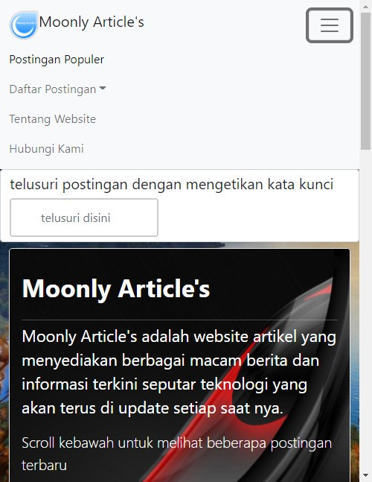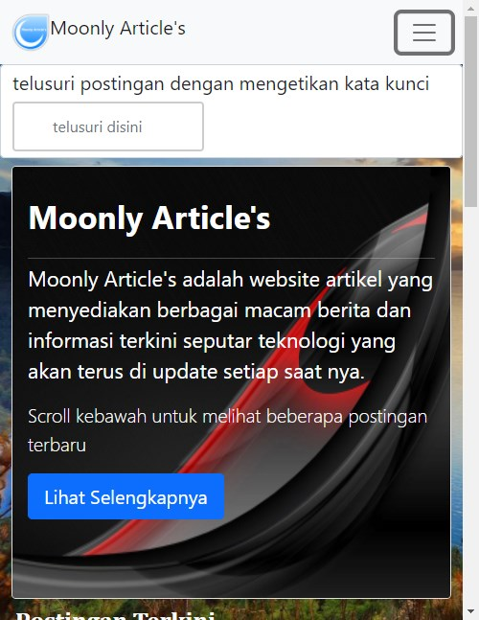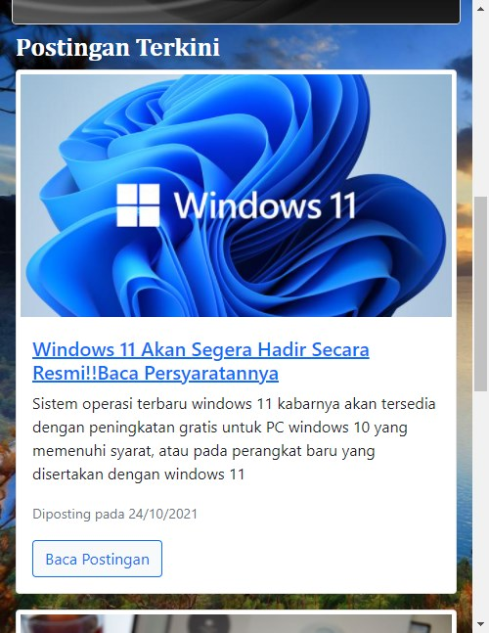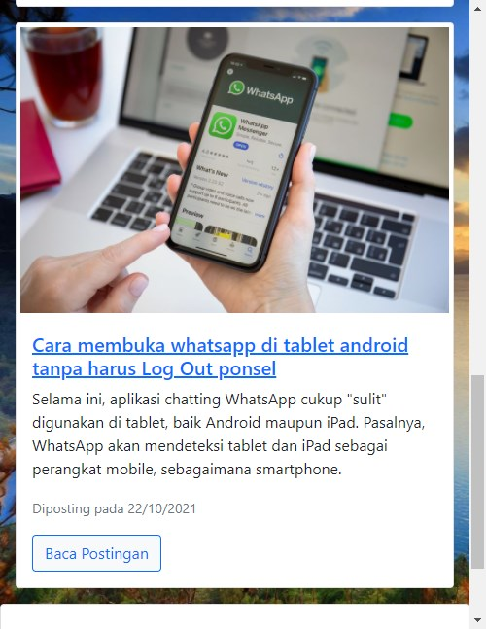

**PREVIEW OF MOBILE APPS**

2.Postingan terbaru

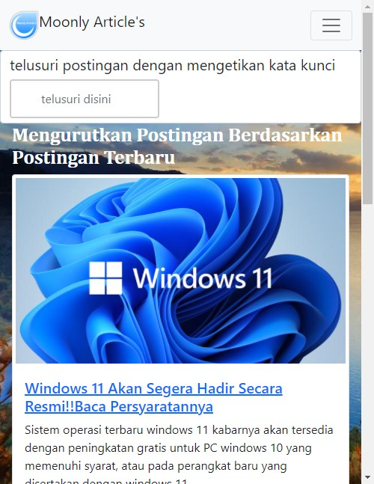

3.Postingan Terlama

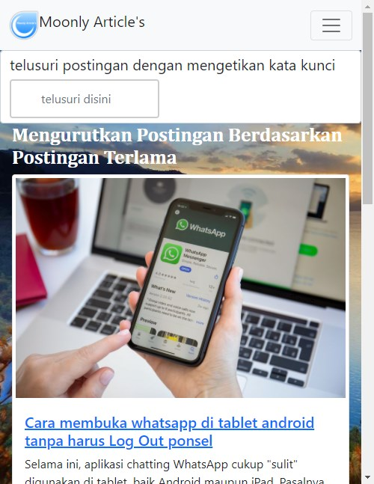

**PREVIEW OF MOBILE APPS**

4.Tentang Website

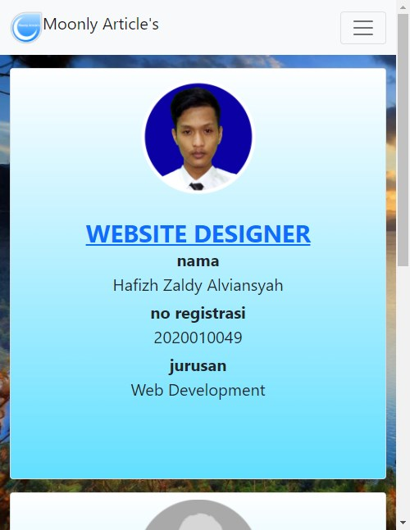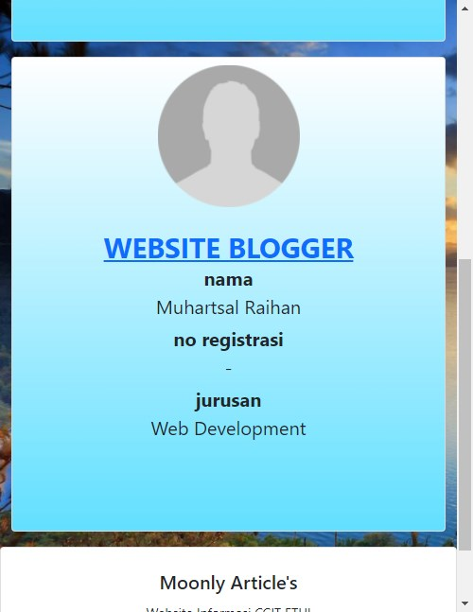

**PREVIEW OF MOBILE APPS**

4.Hubungi Kami

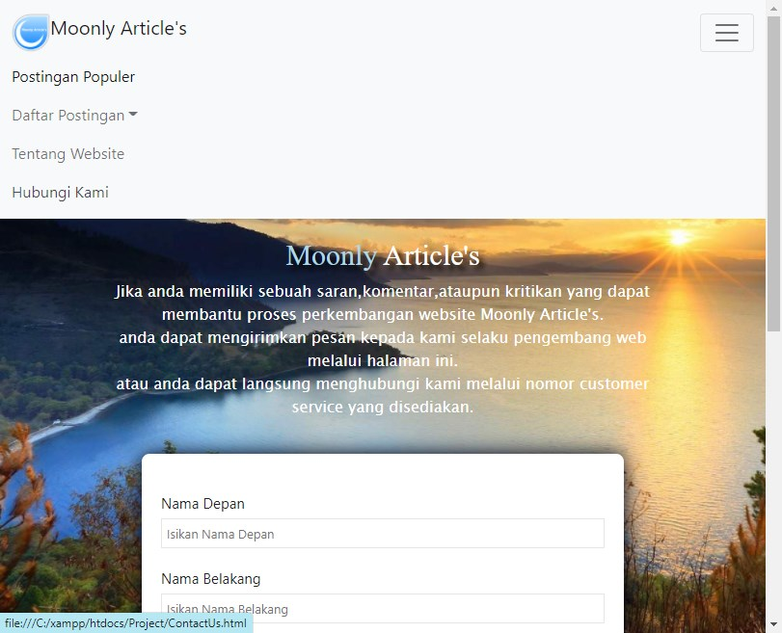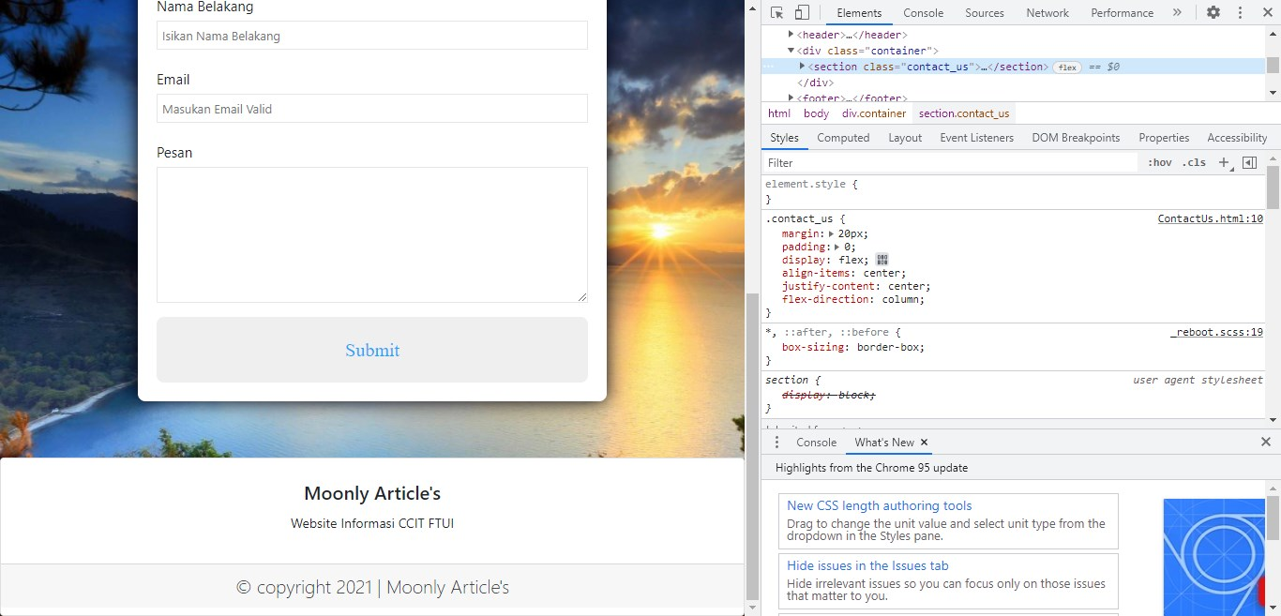

**PREVIEW OF MOBILE APPS**

5.Article

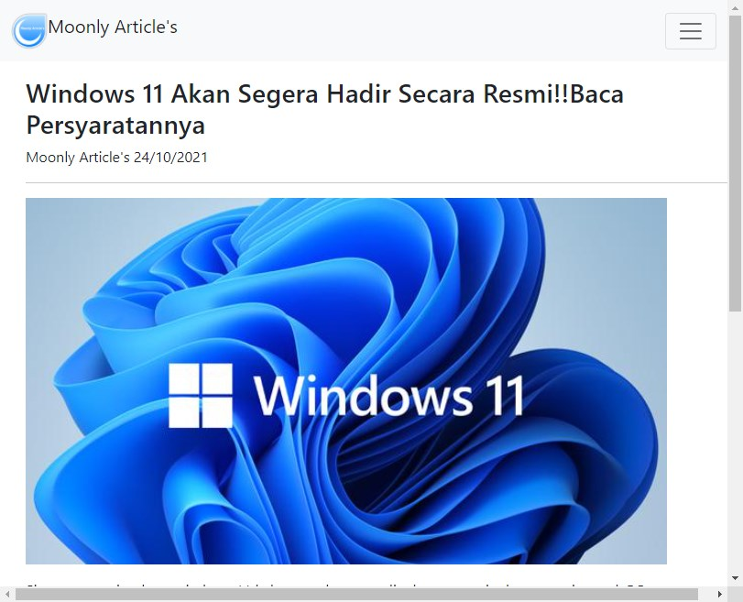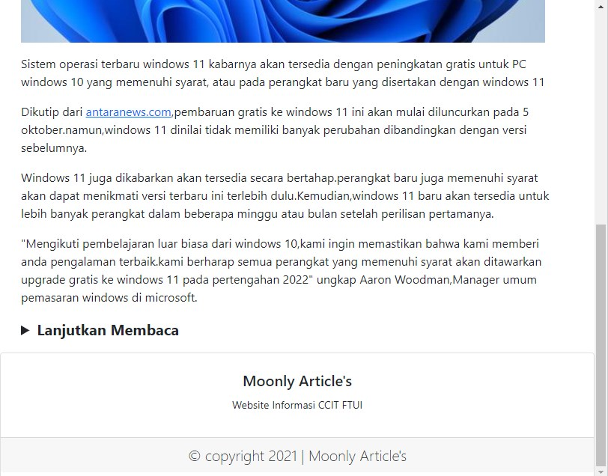

**CONFIGURATION**

**Hardware:** IntelCore i7-2600, RAM 8GB, Geforce GTX 750Ti,MSI

**Operating System :** Windows 10

**Software:** Visual Studio, Notepad++

|  |  |  |
| --- | --- | --- |
| **PROJECT FILE DETAILS** | | |
| S.No | File Name | Remarks |
|  | MAKALAH PROJECT MOONLY ARTICLES |  |